# EX. No.: 1 Install VirtualBox/VMware Workstation with different Date: flavours of Linux or windows OS on top of windows.

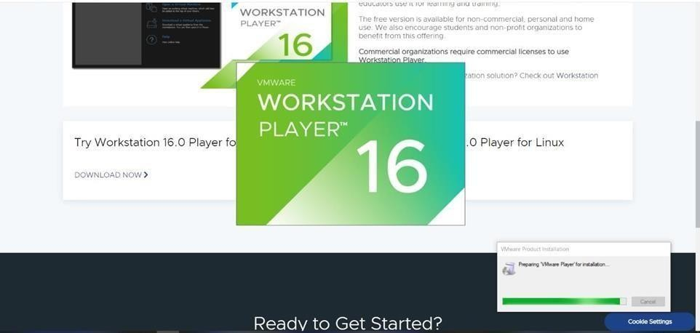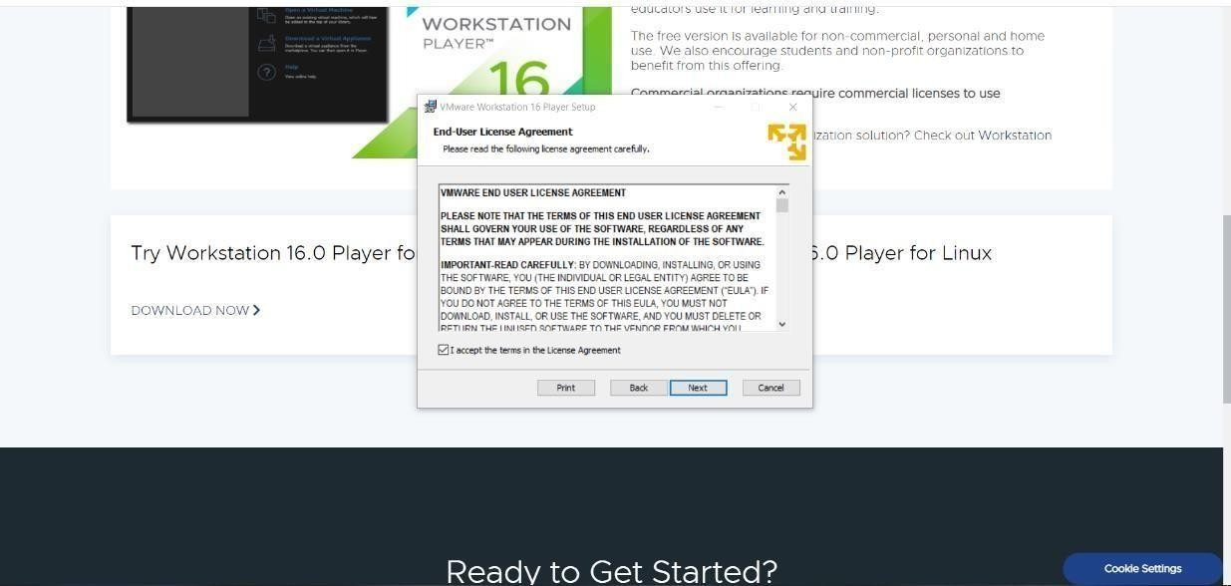

## Aim:

## Procedure:

**Downloading and installing VMware**

Step 1: Download the latest version of VMware workstation from the official VMware site for windows or Linux. Here we are downloading VMware Workstation 16 player.

Step 2:

Install VMware

Step 3: Browse and change the path of installation if needed and check the boxes of necessary features and then click Next.

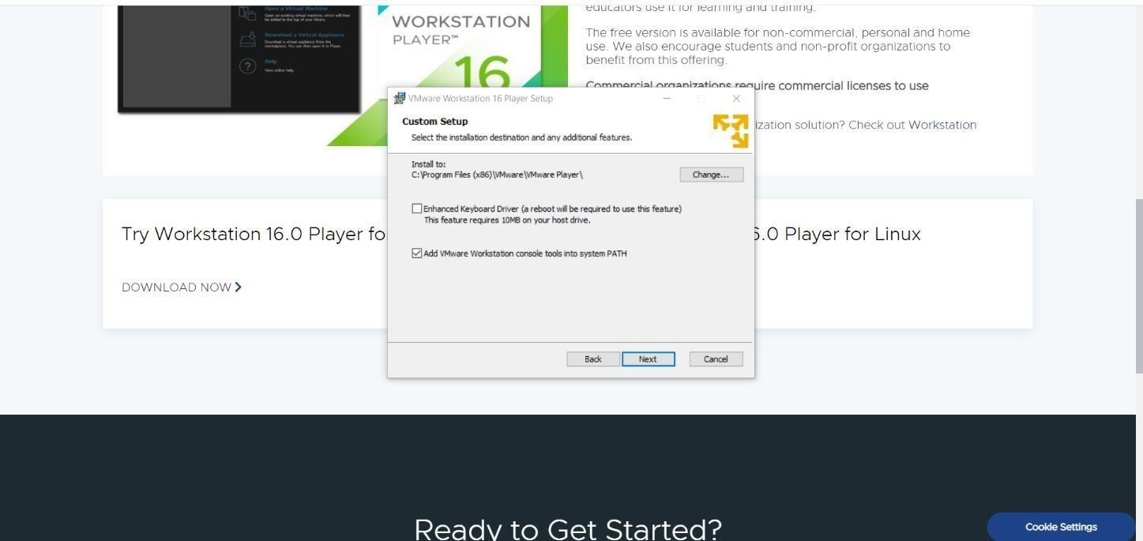

Step 4: Edit default settings that can improve your user experience and then click Next.

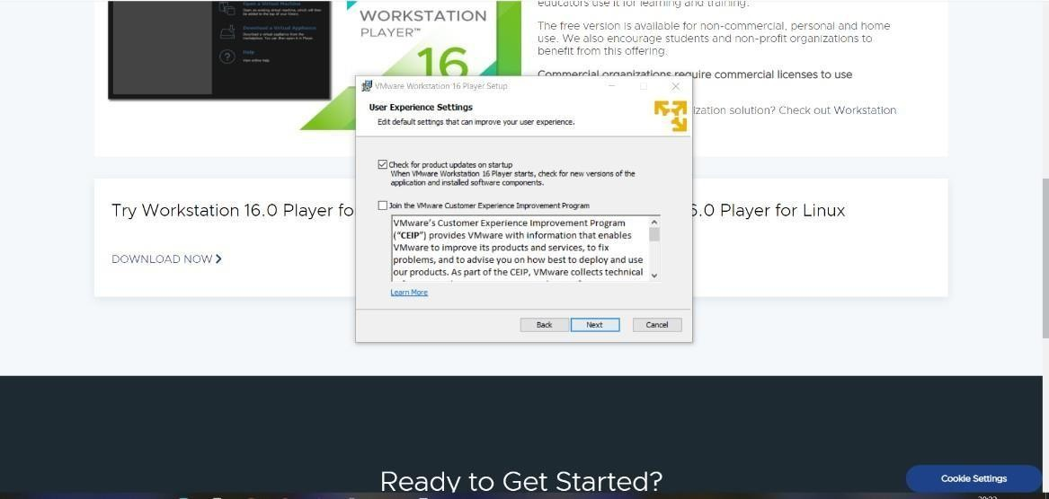

Step 5: Create shortcuts for VMware workstation 16 player in desktop or start menu or both if needed and click Next.

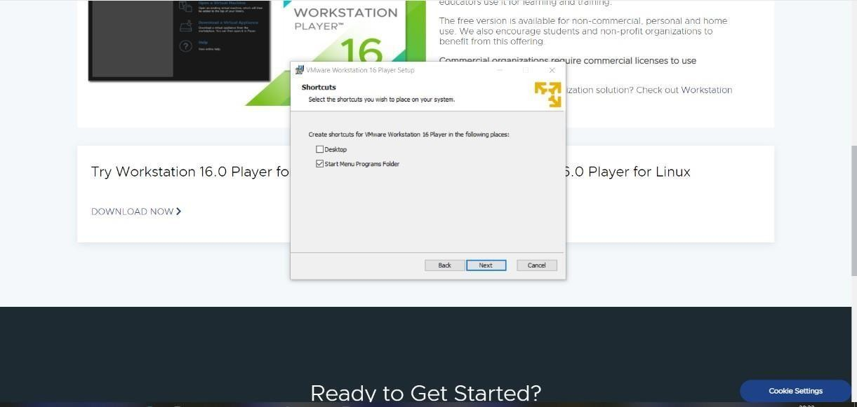

Step 6: Now you are finally ready to install the VMware Workstation 16 player and click Install.

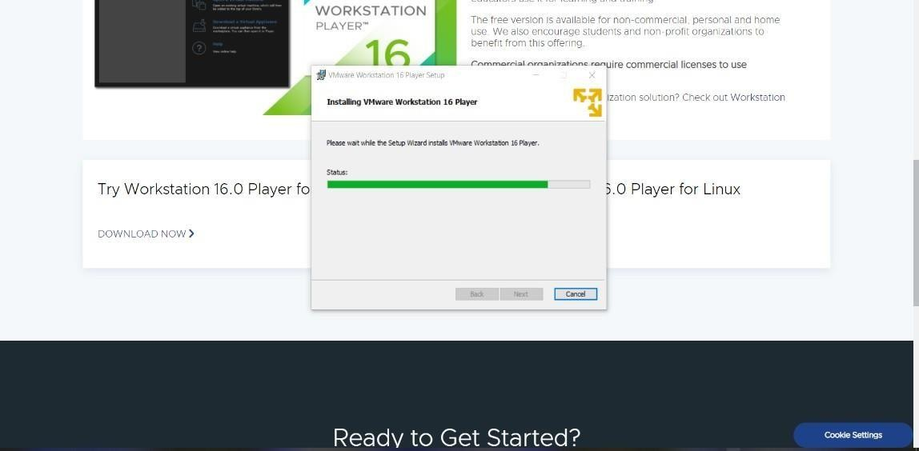

Step 7: Now the VMware Workstation 16 player Setup Wizard is complete if you have license click License or click Finish.

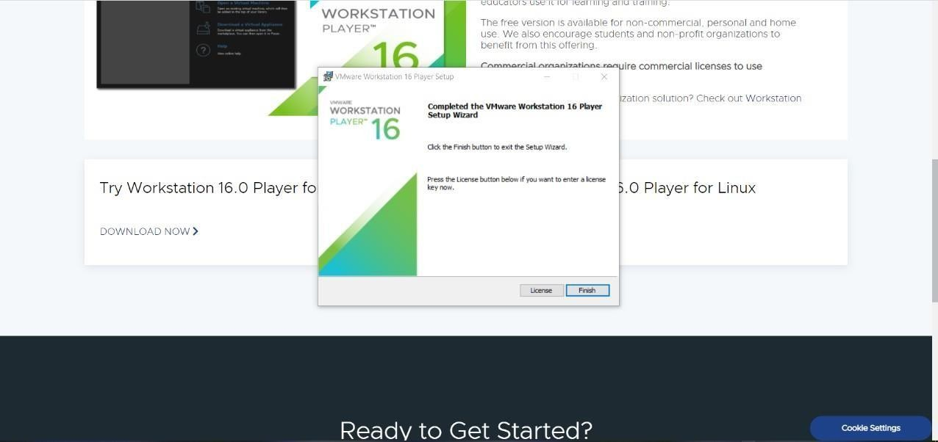

## Downloading Ubuntu

Step 8: Now we have to download OS to run above host OS. Here we are downloading Ubuntu from the official site. Ubuntu 20.04 LTS is downloaded

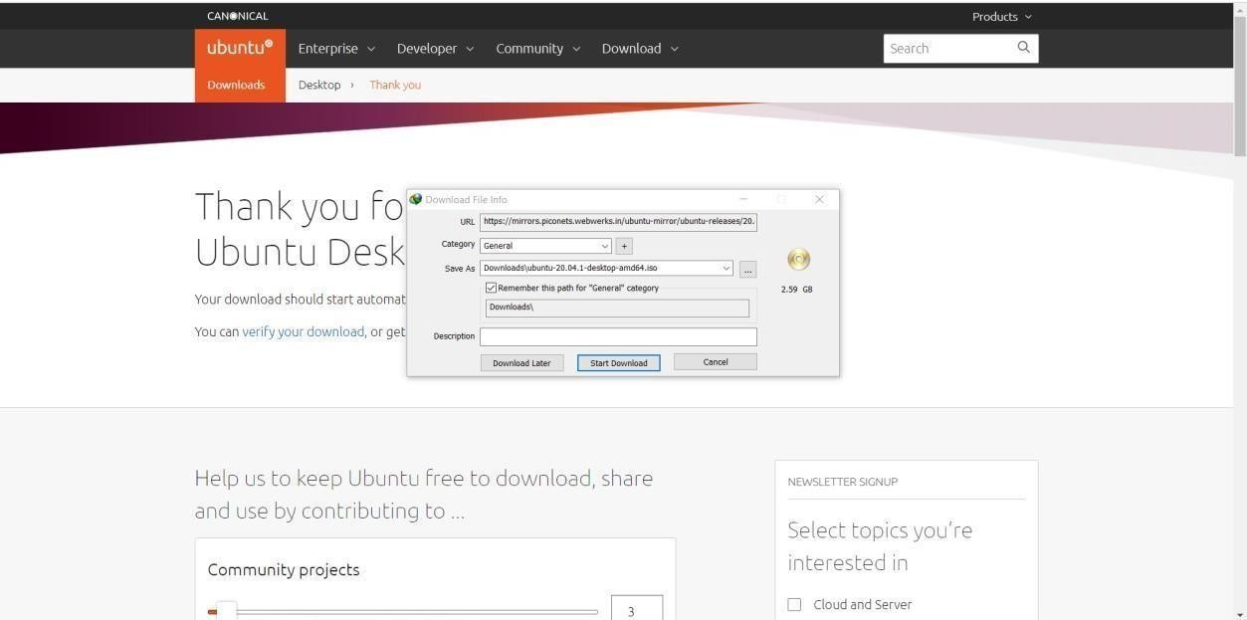

Step 9: Open the VMware workstation 16 player and create a new virtual machine by click on the first logo.

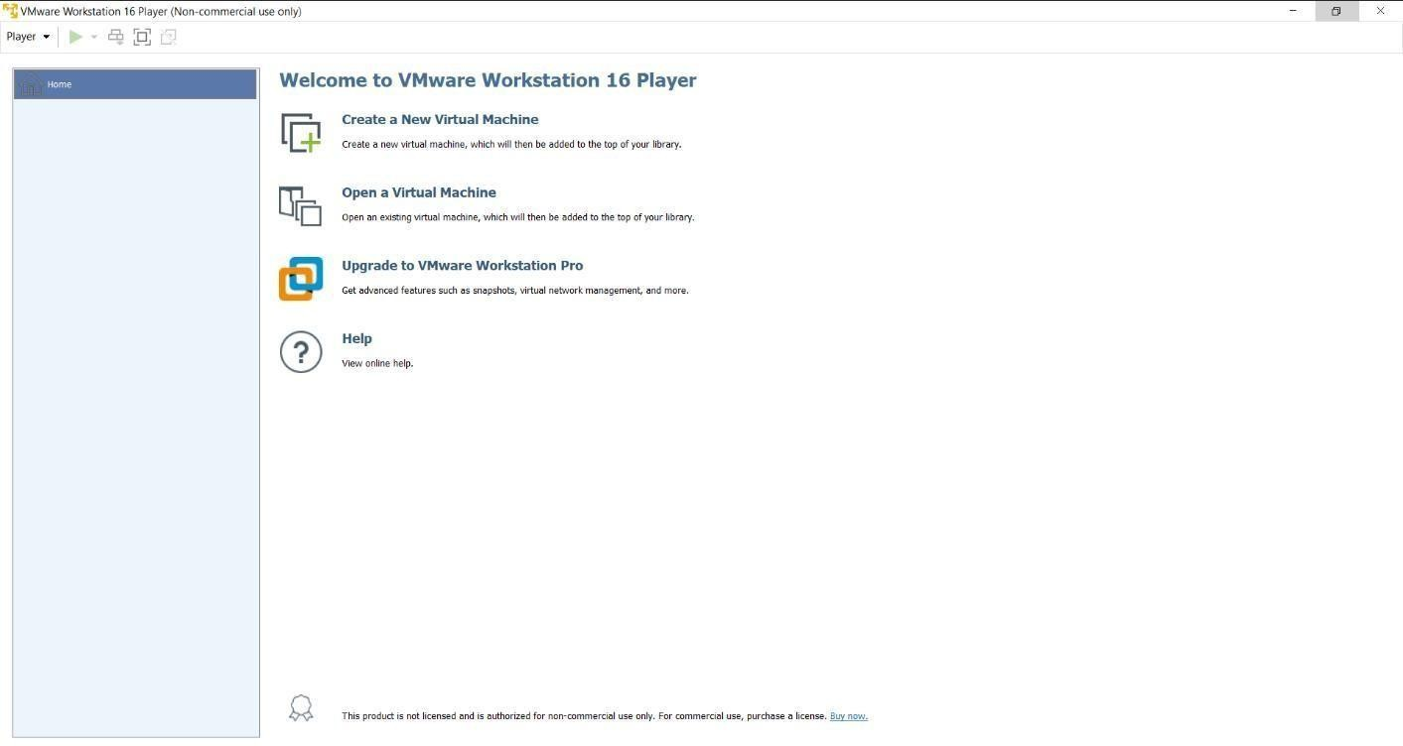

Step 10: Now to install guest OS on VMware check Installer doc image file and browse the path where the Ubuntu is downloaded and then Click Next.

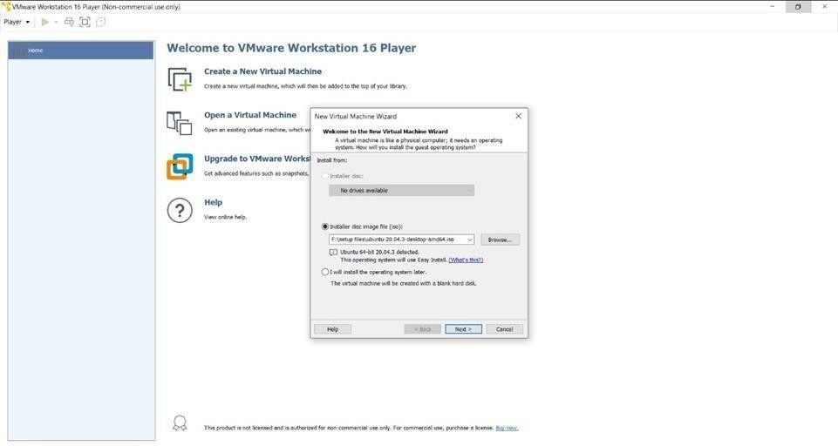

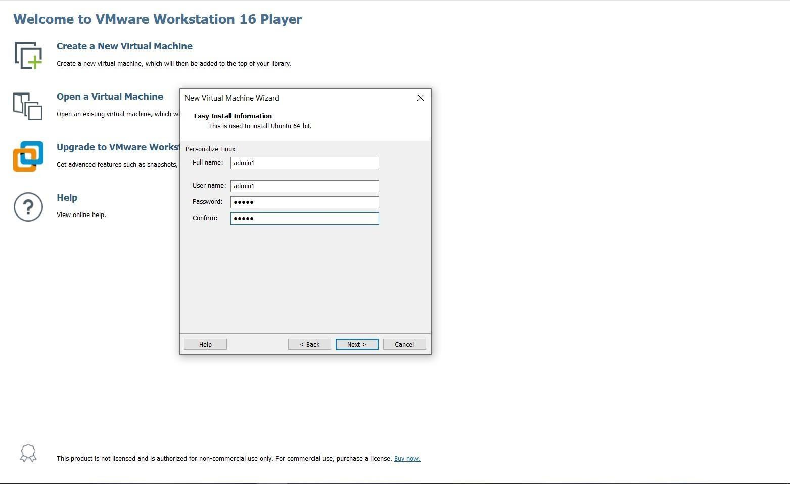Step 11: Fill the install information by adding full name, username and password and then click Next.

Step 12: Name the virtual machine and browse the location of it and then click Next.

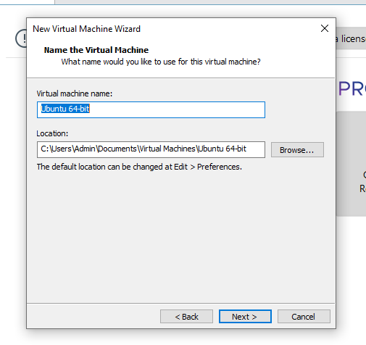

Step 13: Now specify the disk capacity the default maximum disk is 20GB and split virtual disk to multiple files or store as single file and click Next

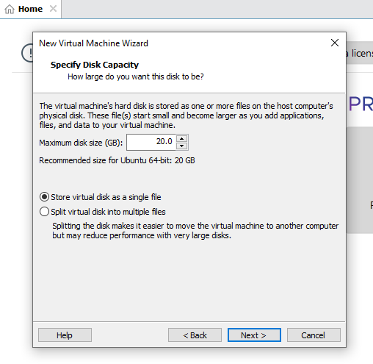

Step 14: Now you are ready to create virtual machine if needed customize hardware and click Finish

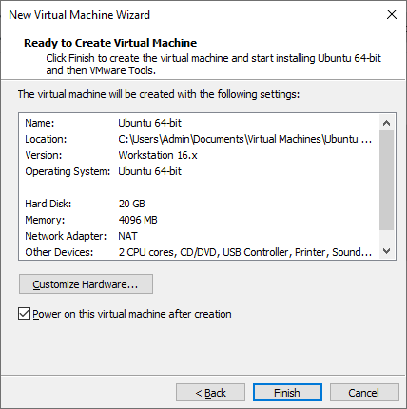

Step 15: Installing Ubuntu on VMware

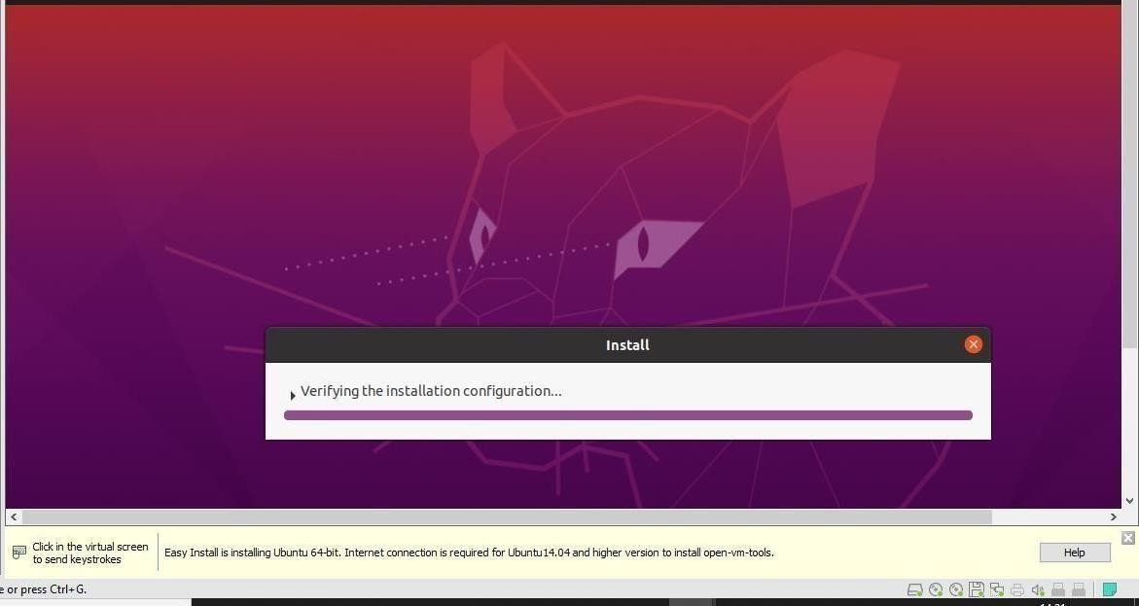

Step 16: Login in by entering the password that you have registered.

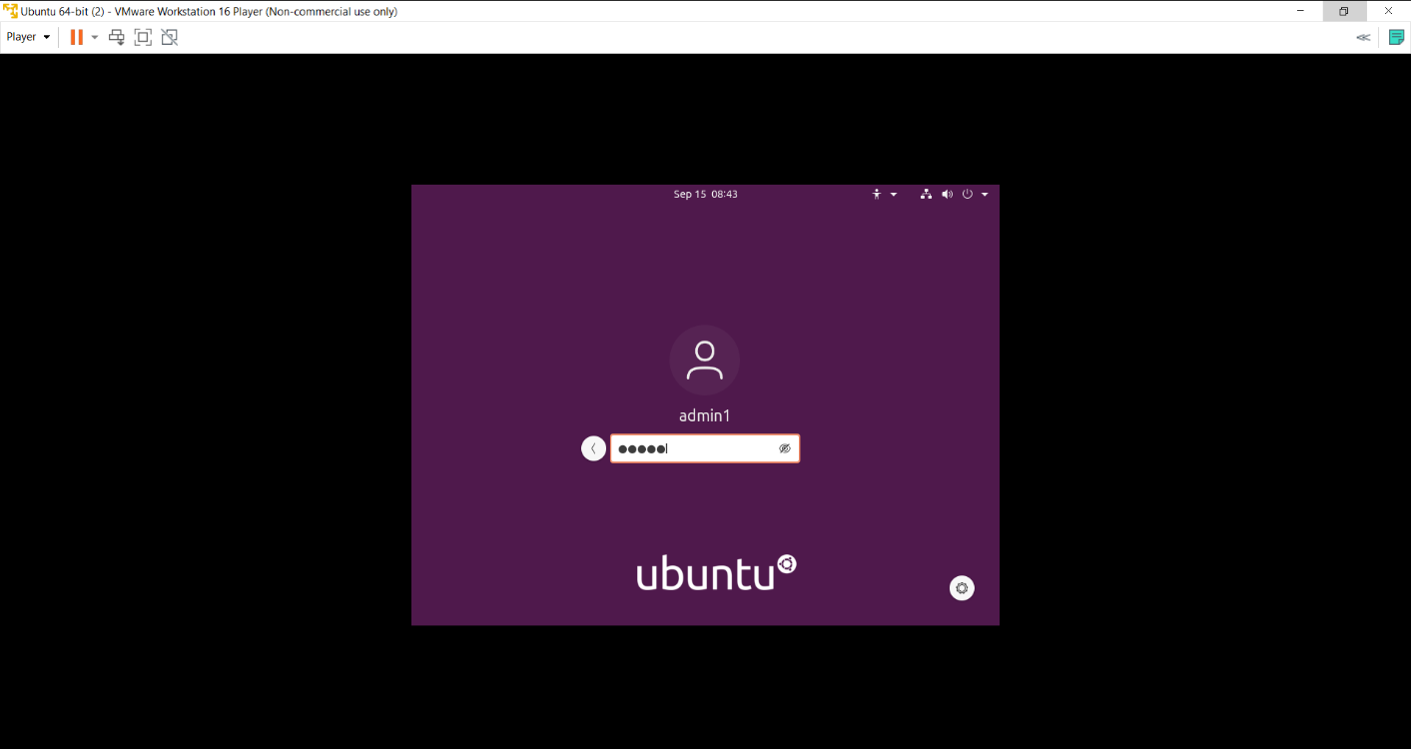

Step 17: Thus, we have installed VMware Workstation with different flavours of Linux on top of windows.

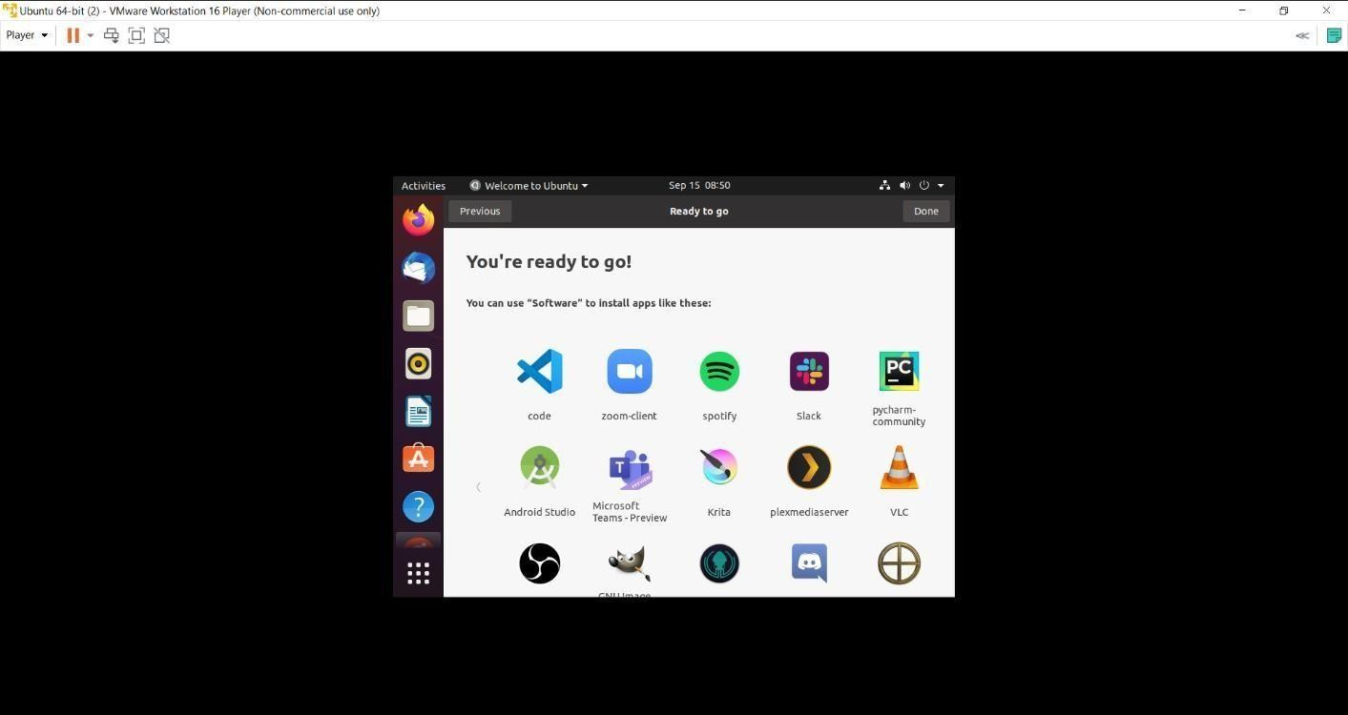

## Result:

# EX. No.: 2 Install a C compiler in the virtual machine Date: and execute a simple program



## Aim:

## Procedure:

Step 1: Open terminal on Ubuntu and install C compiler using the command ***$ sudo apt install gcc.***

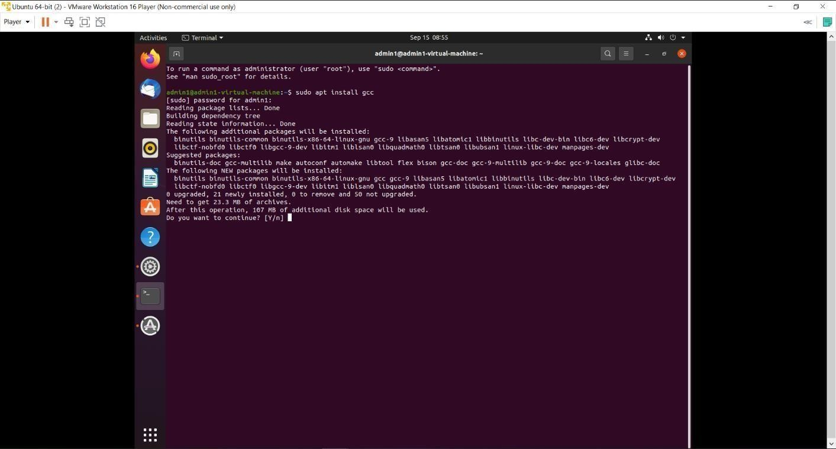

Step 2: Wait for some time to install completely and once it is installed then open editor by

***gedit*** command and type a simple c program

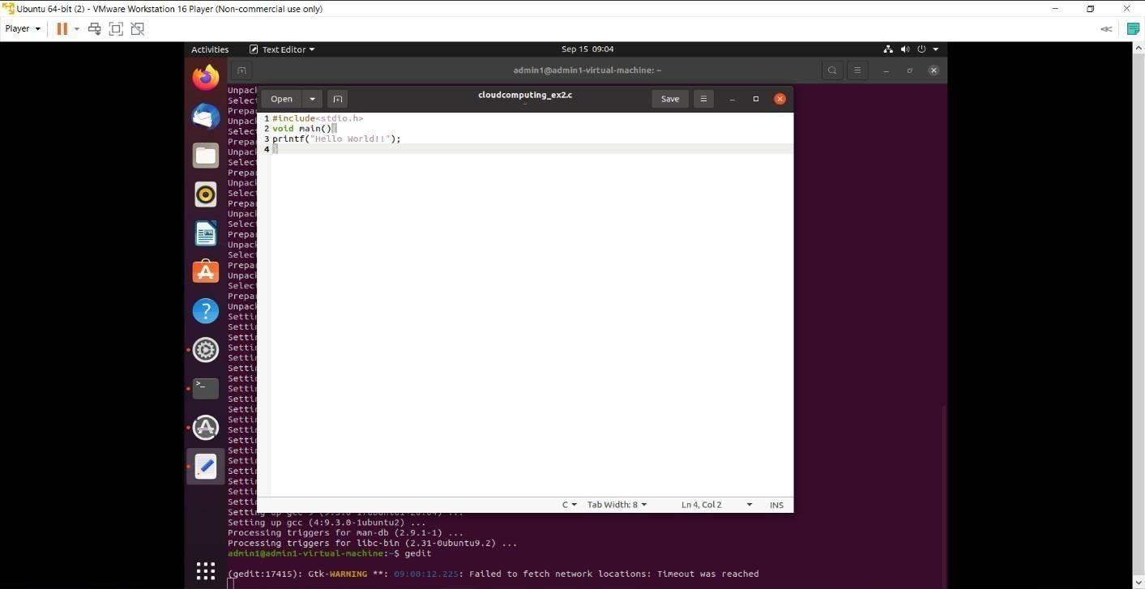

Step 3: Now come to the terminal and compile the c program with the command ***gcc filename.c*** and run the program with command ***./a.out***

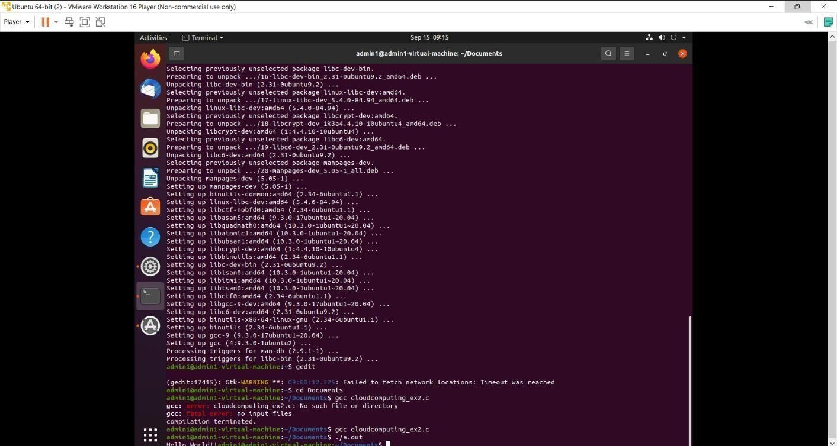

## Result:

# EX. No.:3 Installation of a Google App Engine

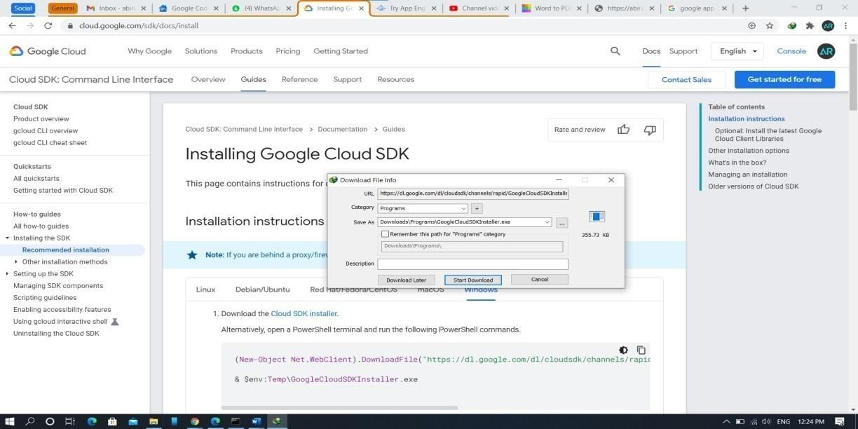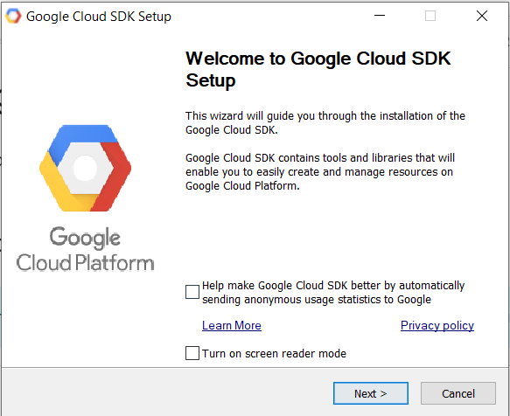

**Date:**

# Aim:

## Procedure:

Step 1**:** To install google app engine. Go to google cloud and download the cloud SDK installer for appropriate OS.

Step 2**:** Launch the installer and follow the prompts. Click on necessary properties and click Next.

Step 3**:** Read terms and conditions of the google cloud platform completely and click I agree.to proceed further.

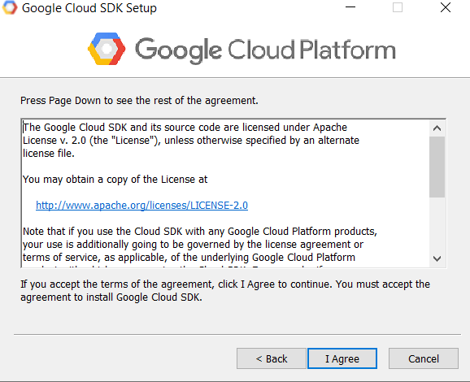

Step 4**:** Select install type either a single user or all users and then click Next.

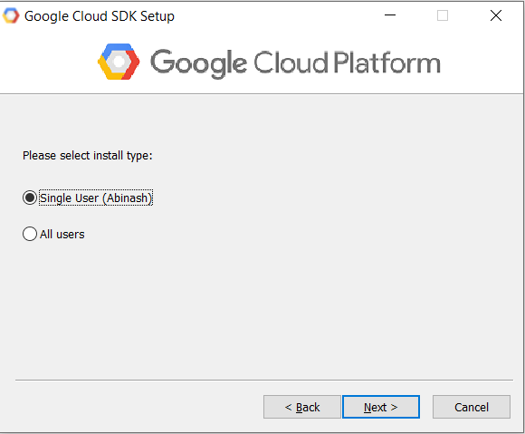

Step 5**:** Change the destination folder path in which you want to install your setup and click next to continue.

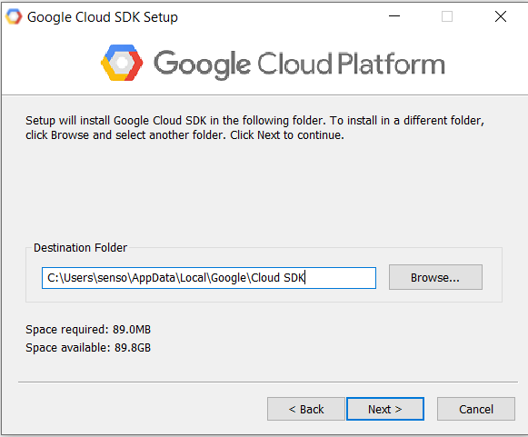

Step 6: Check the components you want to install and uncheck the components you don’t want to install. Then click Install.to start installation.

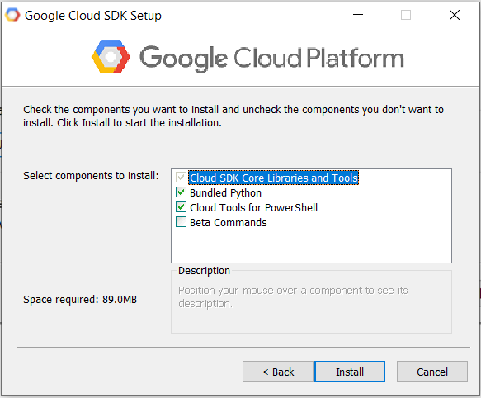

Step 7: After successful installation click next to proceed.

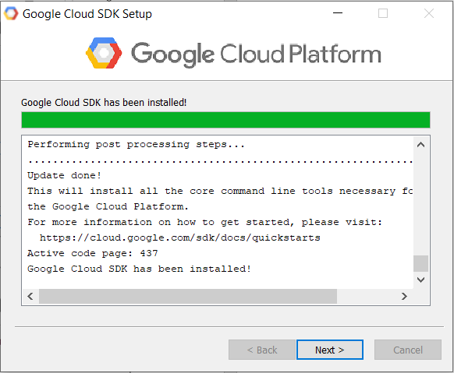

Step 8: Finally check the boxes you need and then click Finish close the setup

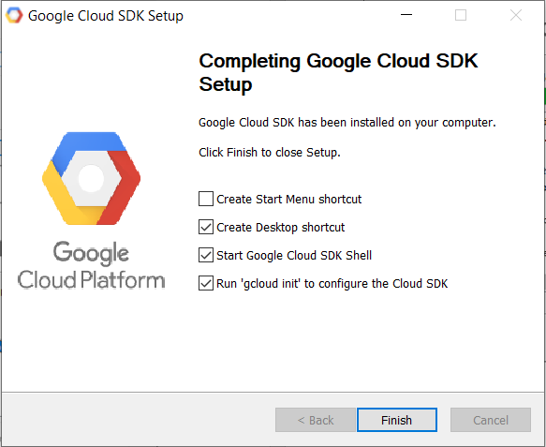

# Result:

# EX. No.: 4 Use GAE launcher to launch the web application Date:

**Aim:**

# Procedure:

Step 1: Create a google cloud account and create a new python project. Clone python using git.

**$ git clone \**

* 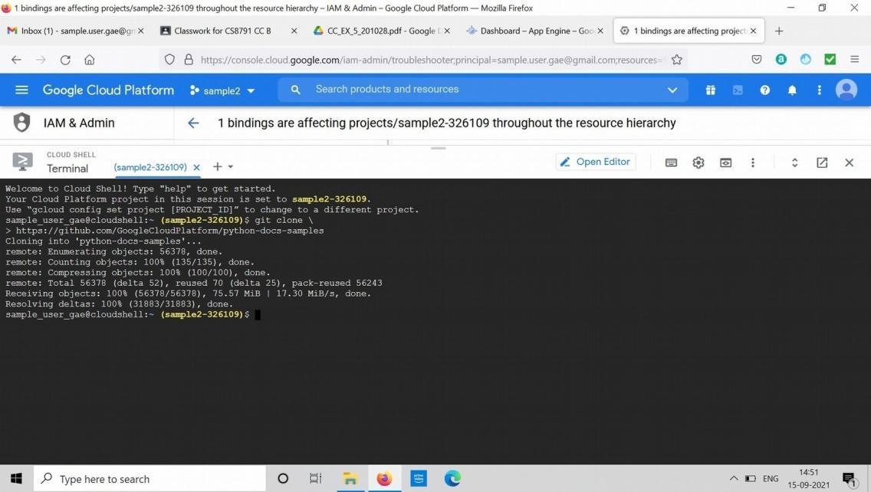[**https://github.com/GoogleCloudPlatform/python-docs-samples**](https://github.com/GoogleCloudPlatform/python-docs-samples)

Step 2: Navigate to hello_world inside python docs samples

**$ cd python-docs-samples/appengine/standarard_python3/hello_world**

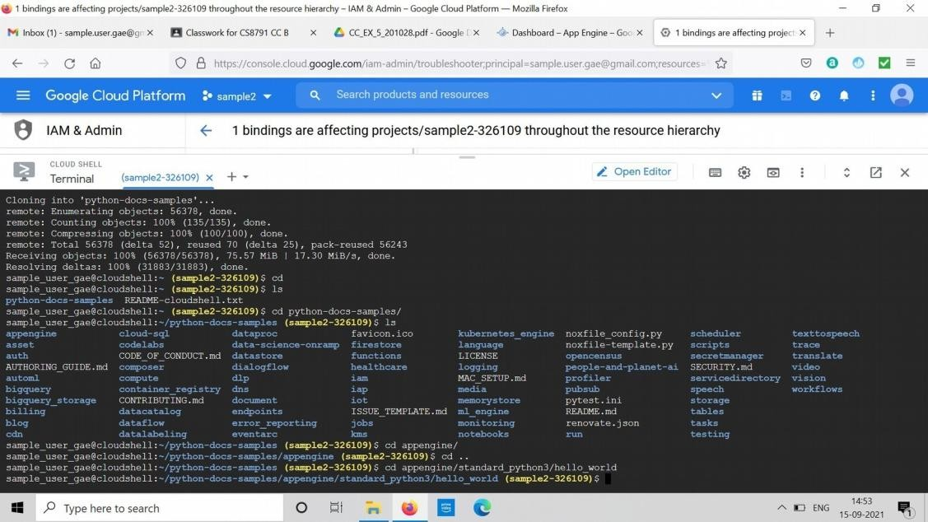

Step 3: Navigate to the default hello world program.

**$ cat app.yaml**

**$ virtualenv --python python3 \**

* 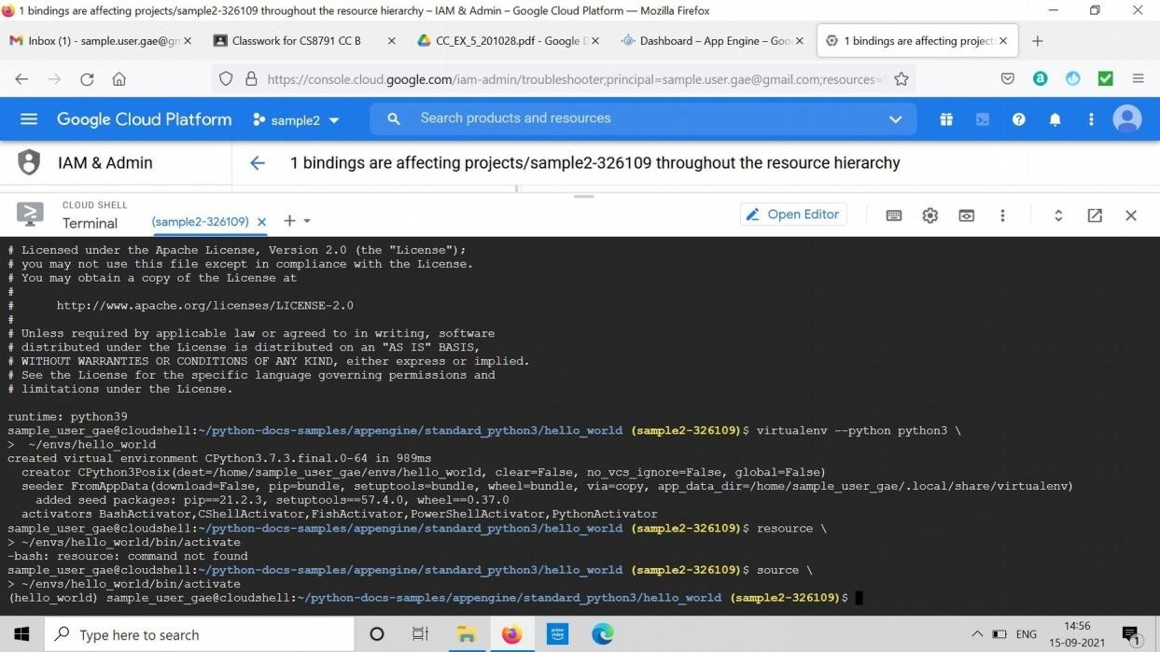**~/envs/hello_world**

Step 4: Run the default hello world program

# $ source \

* **~/envs/hello_world/bin/activate**

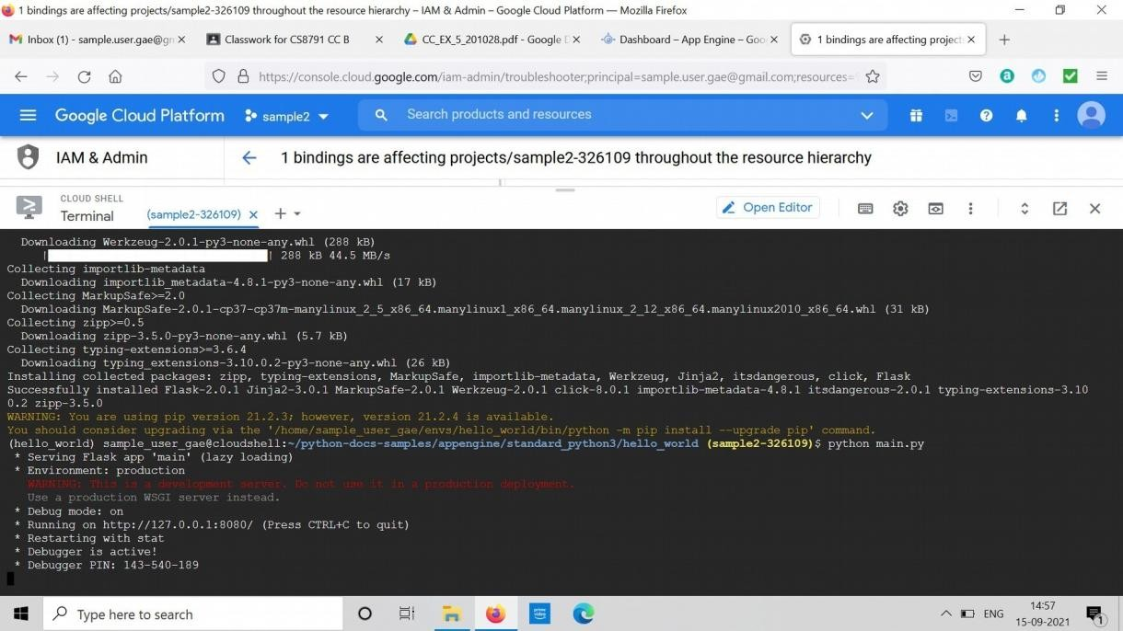

Step 5: Create a new app in gcloud

**$ python main.py**

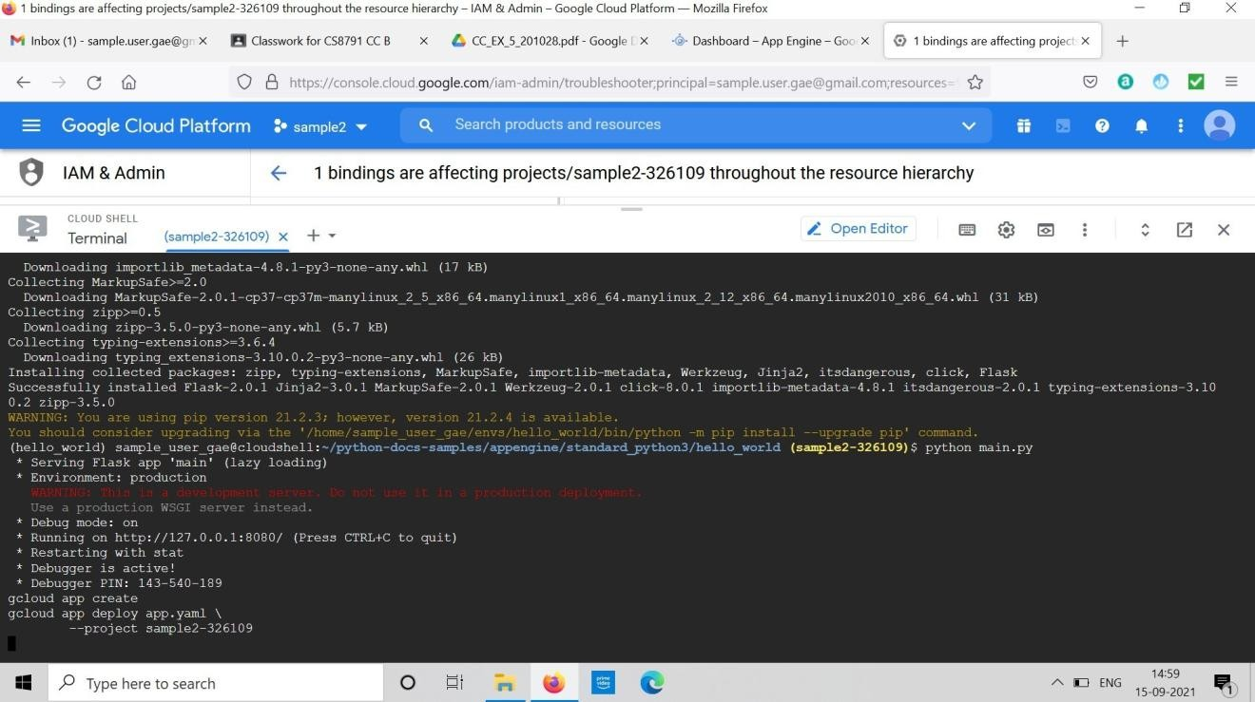

Step 6: Deploy the app

**gcloud app create**

**gcloud app deploy app.yaml \**

**--project sample2-326109**

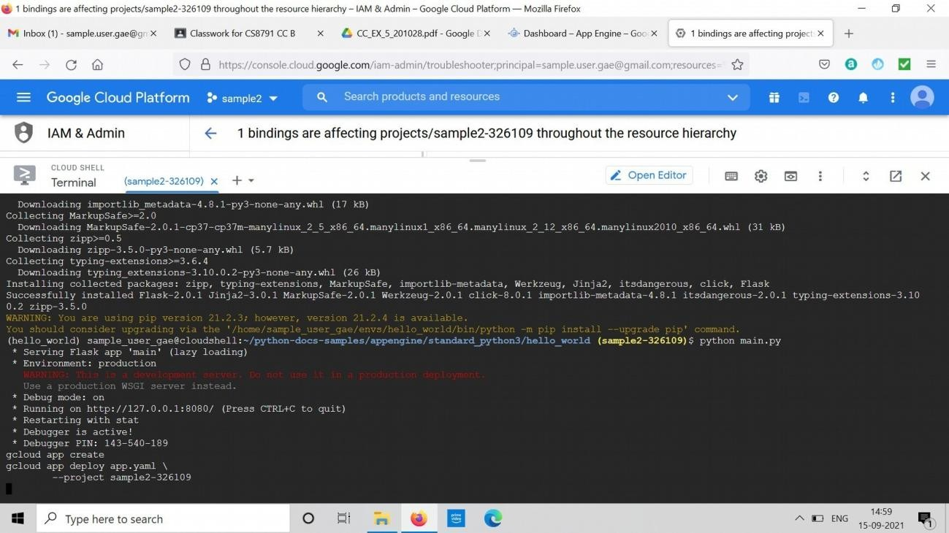

Step 7: Navigate to port 8080 by clicking Preview on port 8080

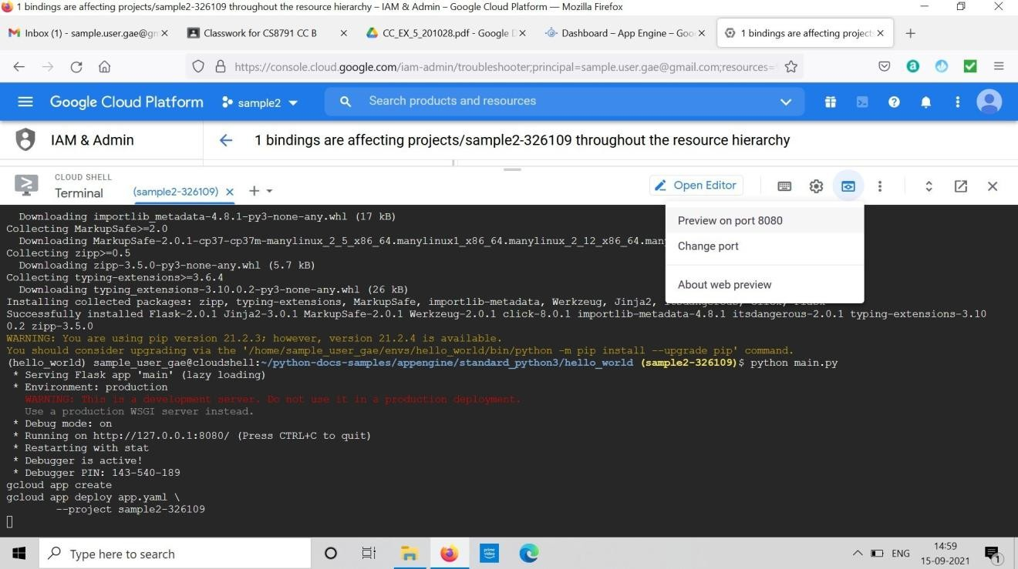

Step 8: On port 8080, we can view the deployed app.

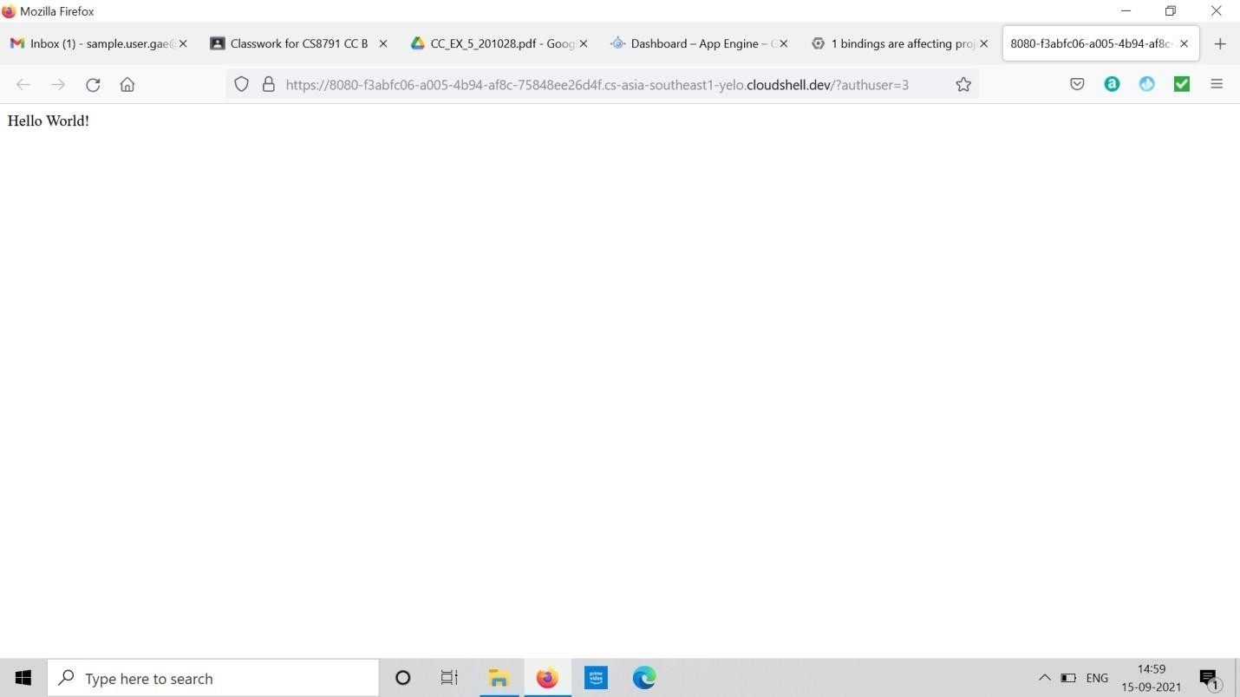

# Result:

# EX. No.: 5 Simulate a cloud scenario using CloudSim and run Date: a scheduling algorithm

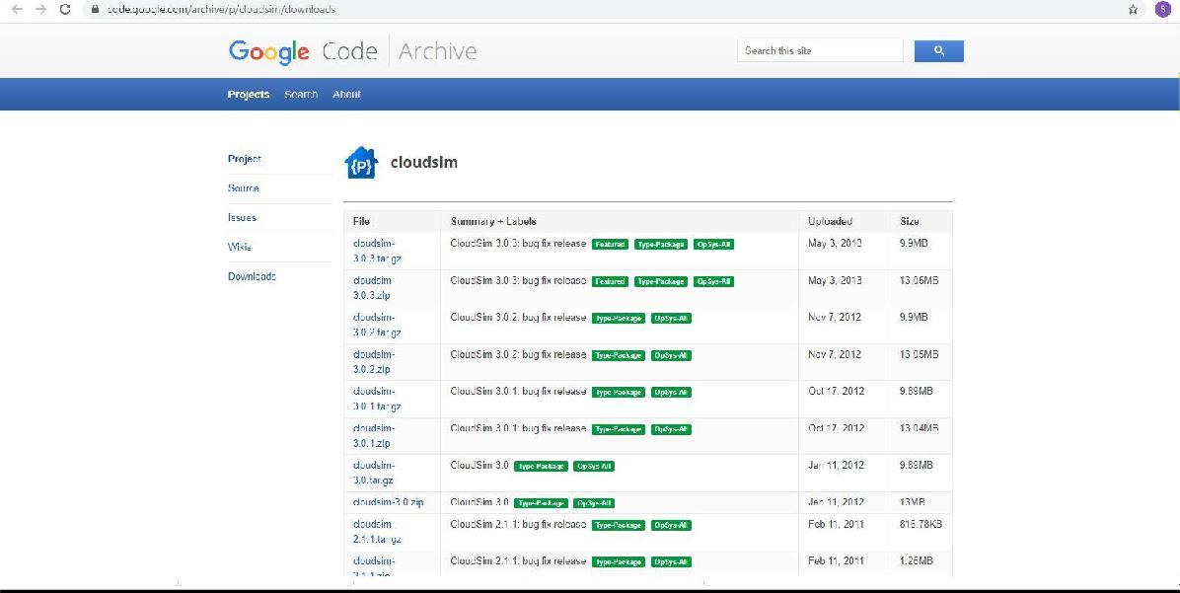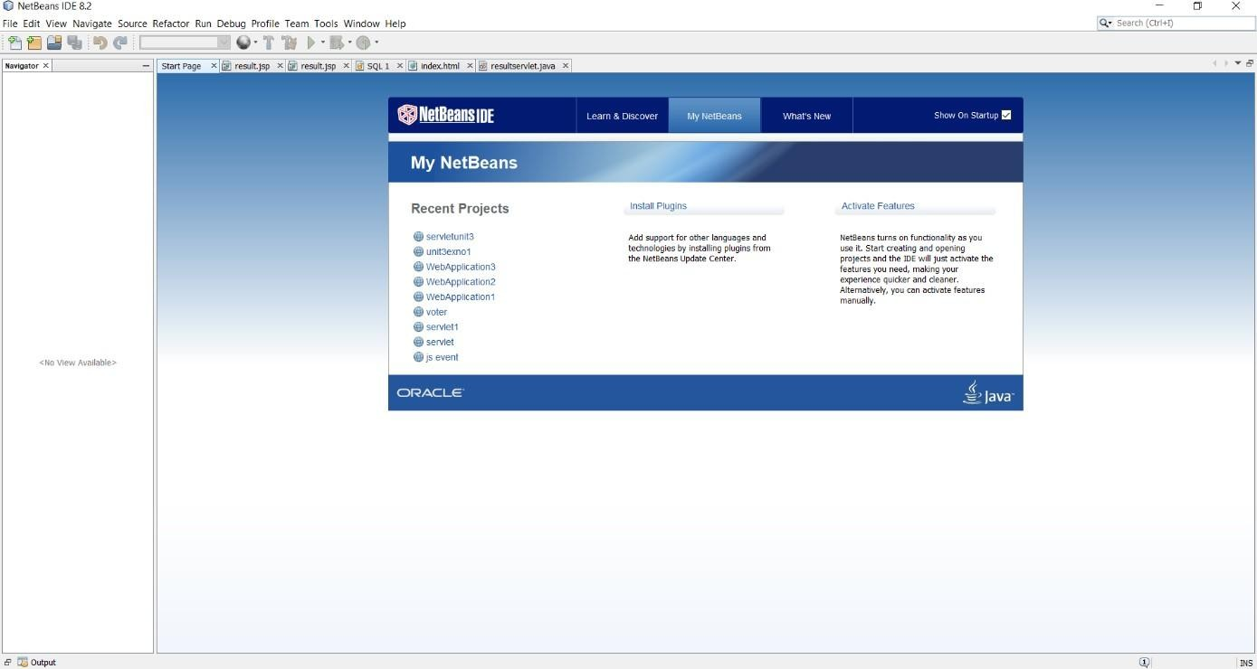

**Aim:**

# Procedure:

Step 1: Download Cloudsim zar file from google code

Step 2: Open NetBeans IDE

Step 3: Click -> new project

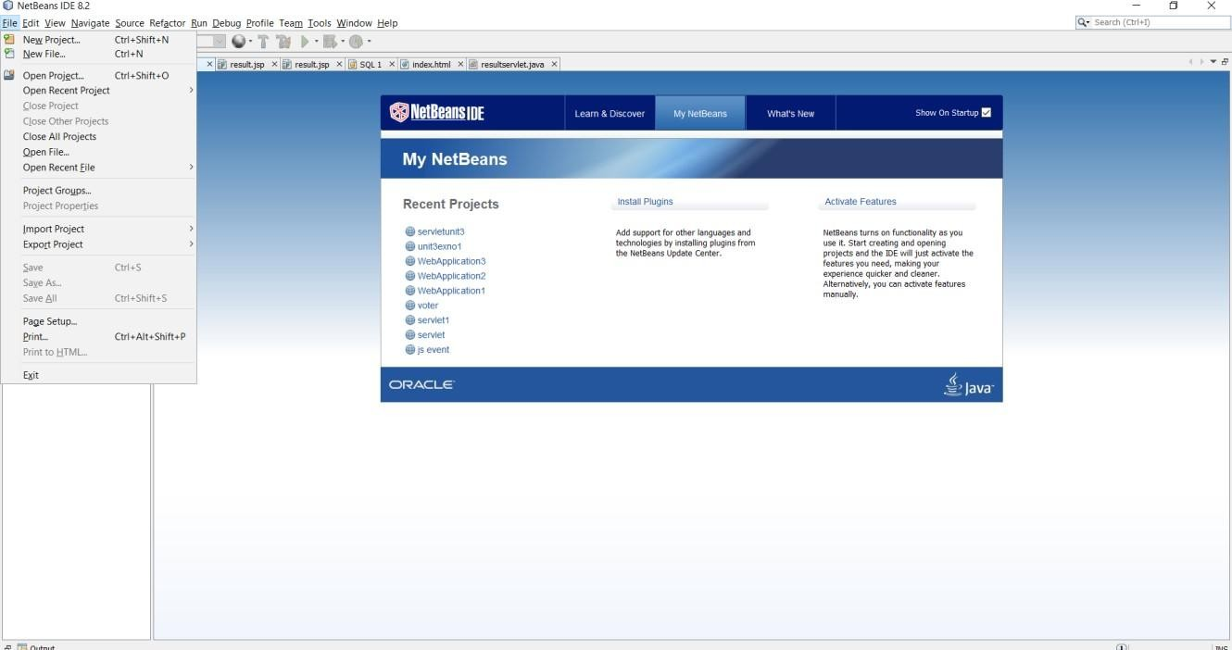

Step 4: Create a Java Application

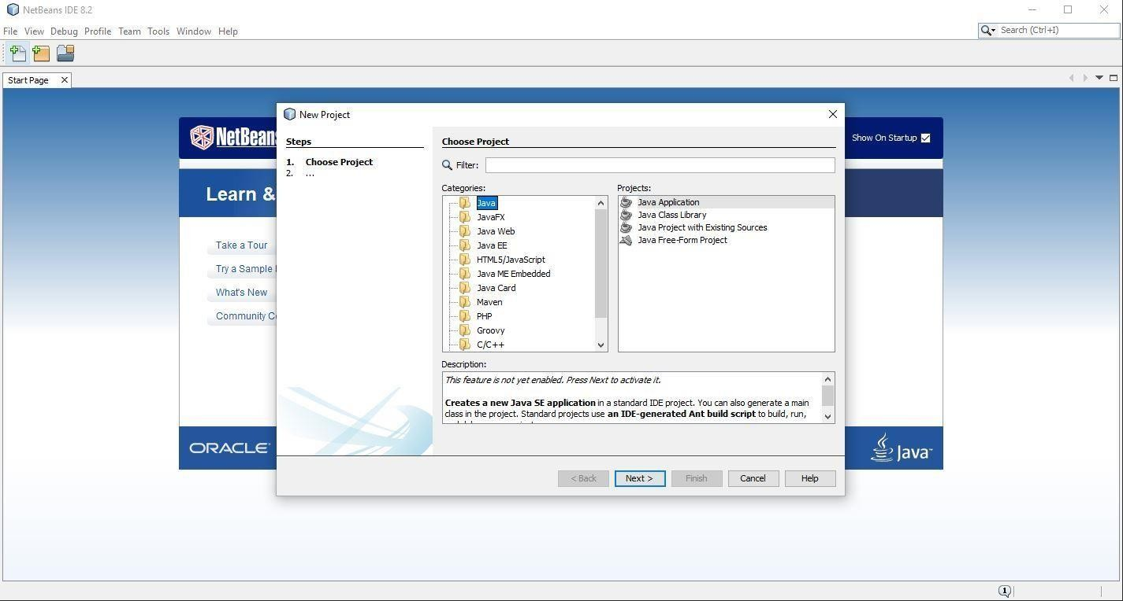

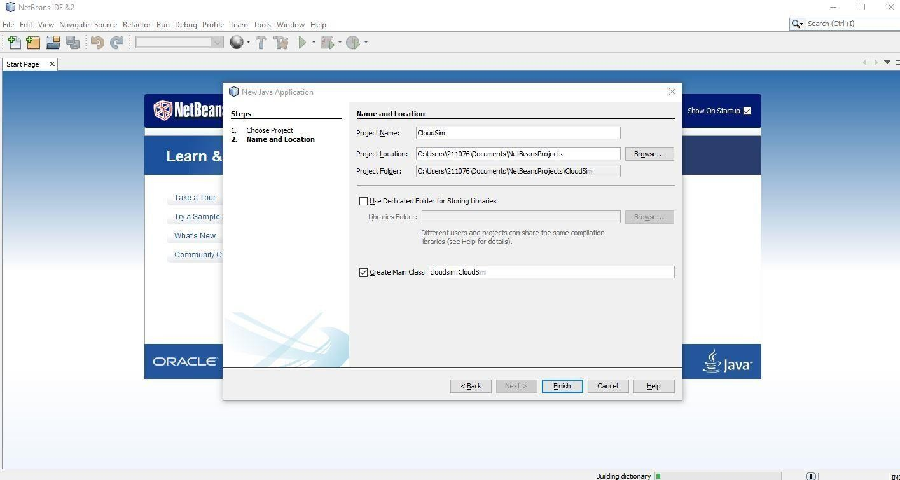

Step 5: Right-click Libraries and Click on Add JAR and Click on cloudsim JAR

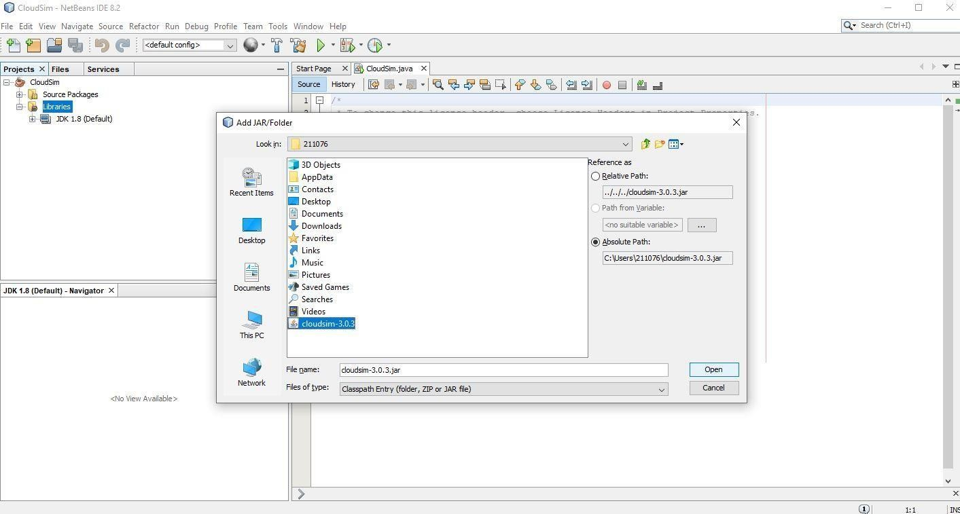

Step 6: Type in the code

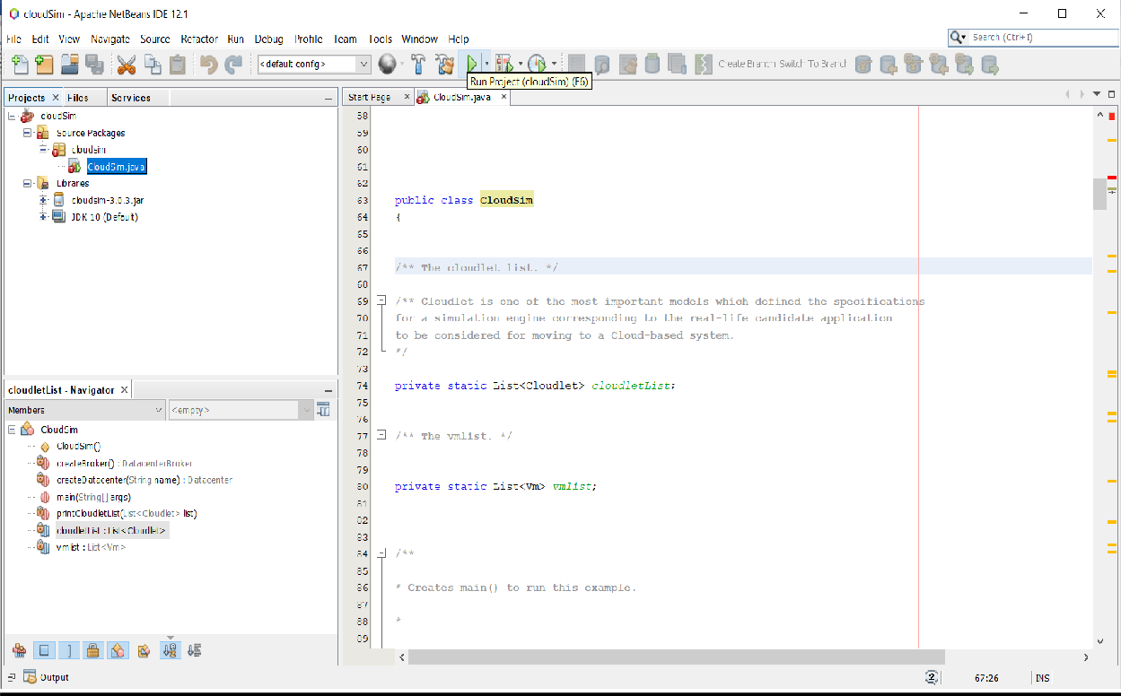

Step 7: Save and run the file

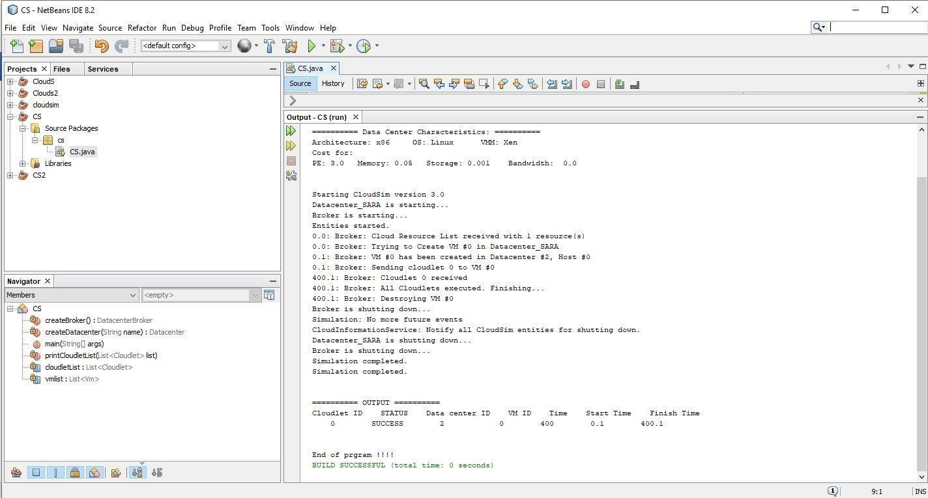

Step 8: Similarly follow the same above steps for the next program and run that program

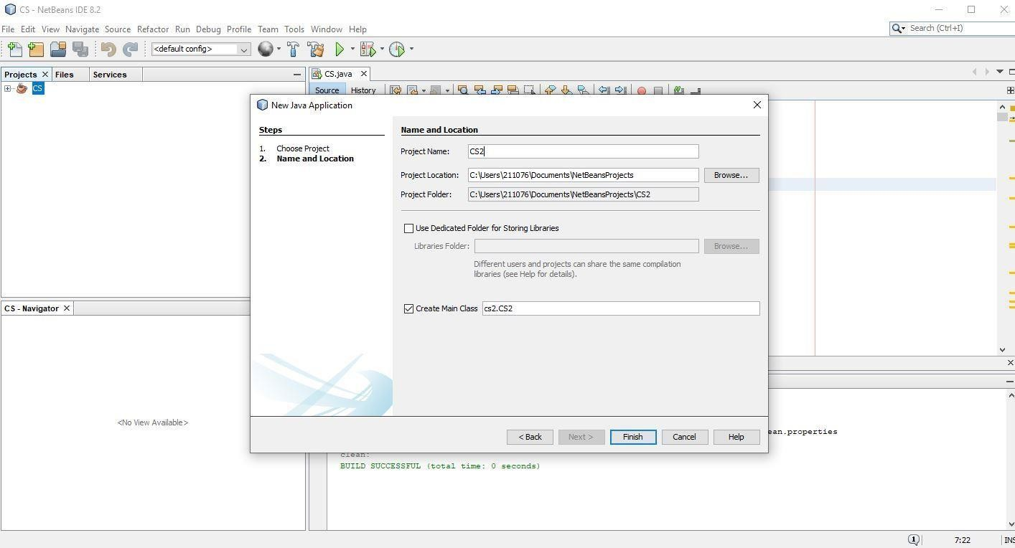

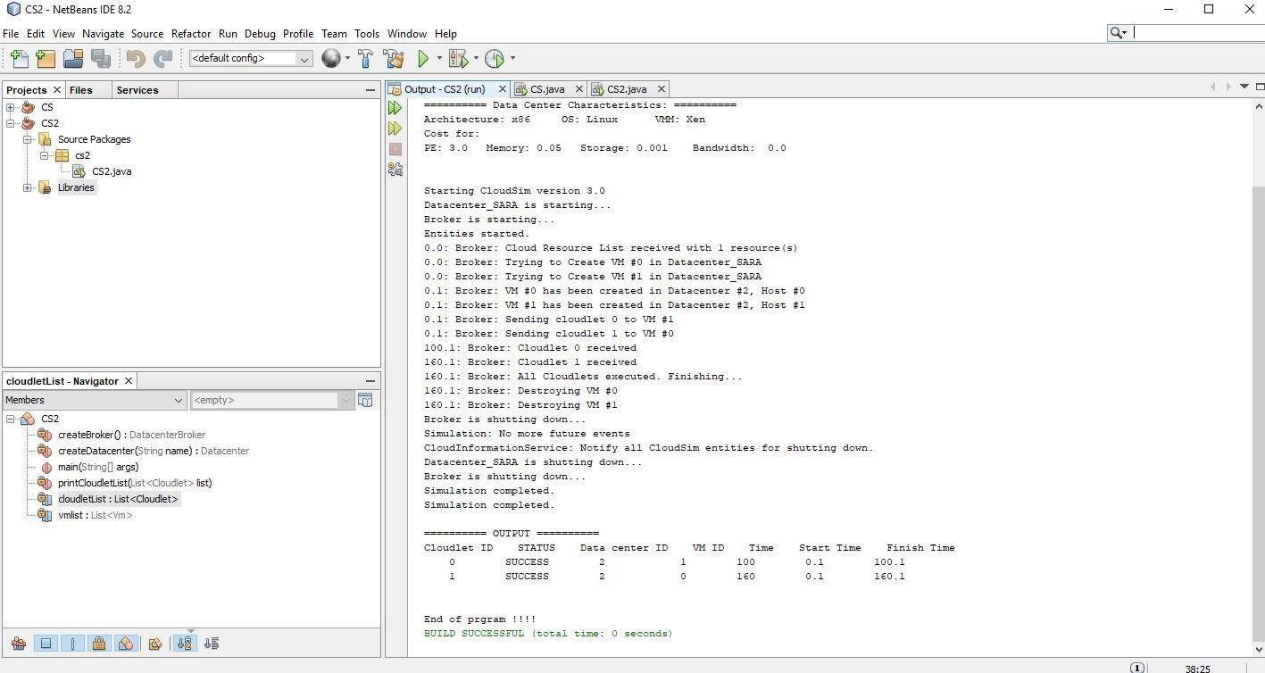

# Result:

# EX. No.: 6 Transfer the files from one virtual machine to Date: another Virtual machine

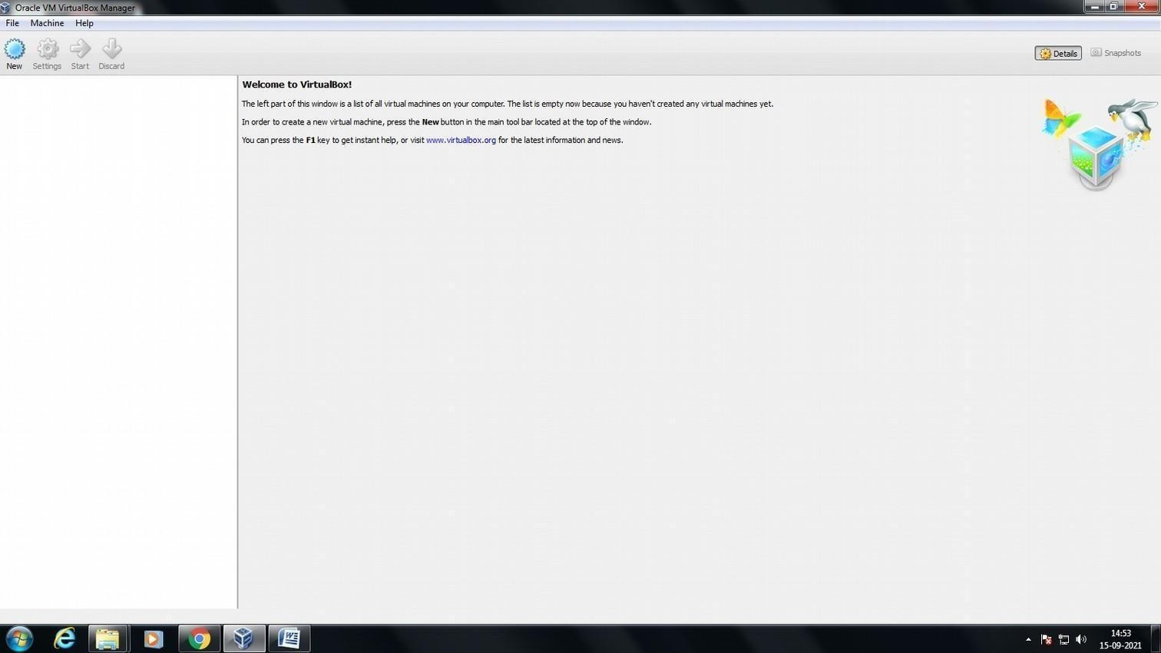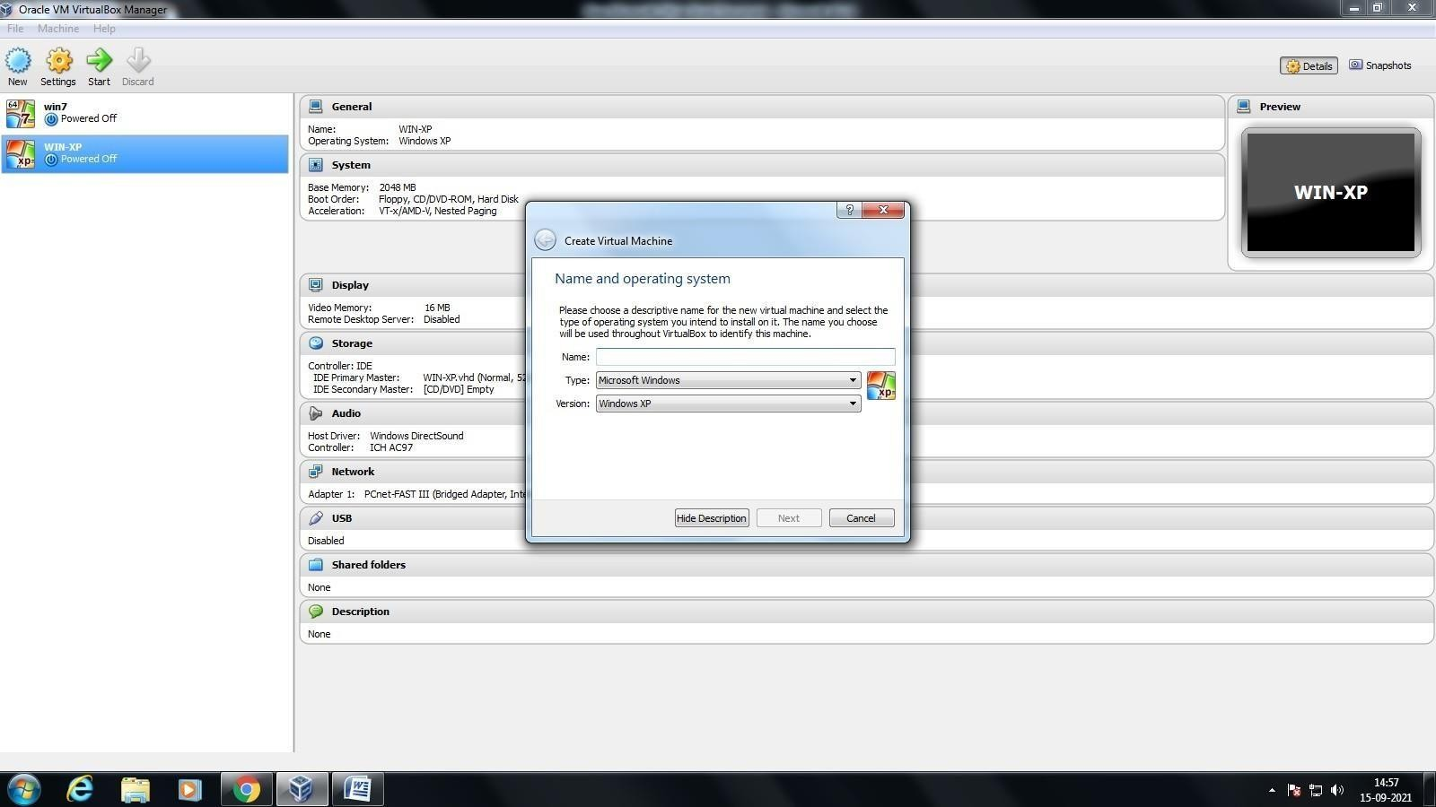

## Aim:

## Procedure:

Step 1: Open VM virtualBox Workstation

Step 2: Create a two Virtual machines and name it.

Step 3: Define the required specification for the virtual machines.

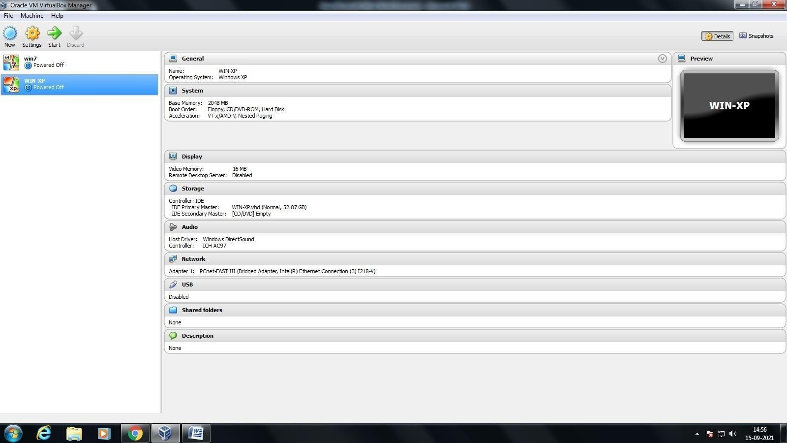

Step 4: Start the virtual machines.

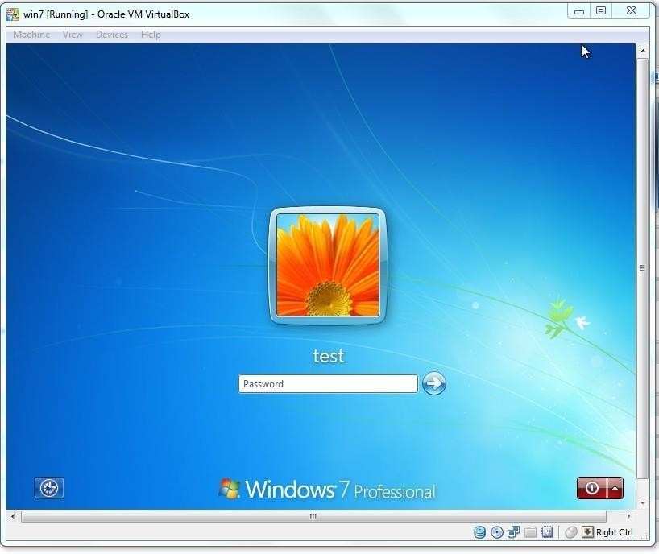

Step 5: Create a Folder in virtual machine 1 and name it.

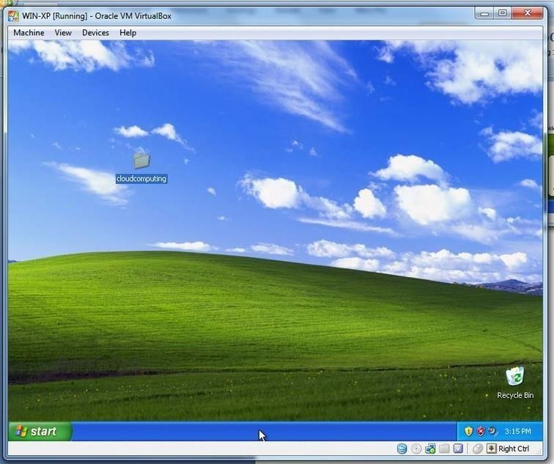

Step 6: Right click on the folder and go to properties.

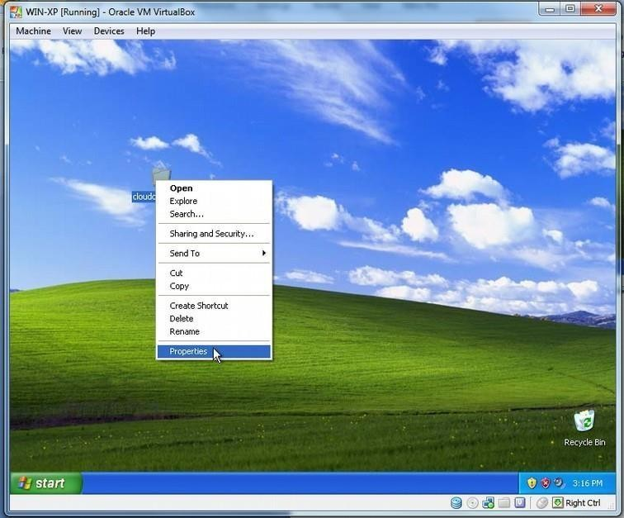

Step 7: Select the sharing option and enable network file sharing.

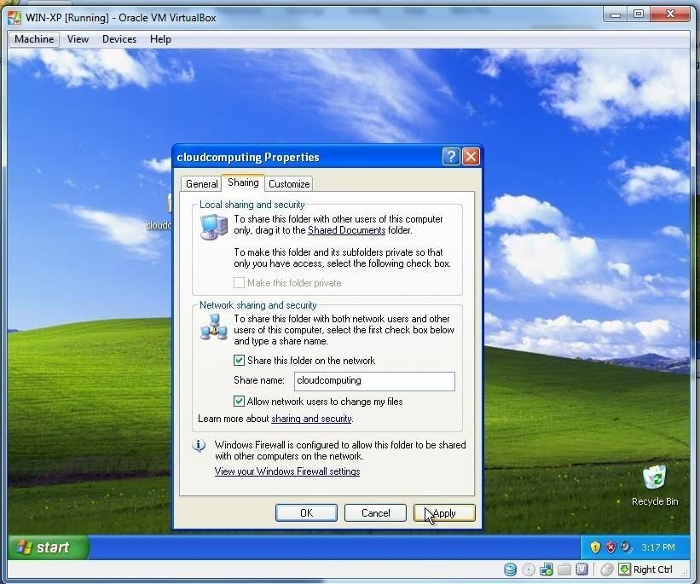

Step 8: Click yes on the dialog box that is popped up.

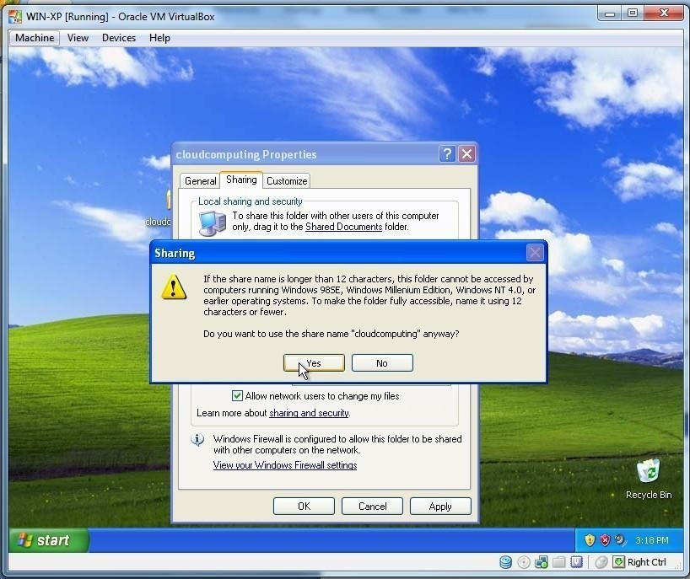

Step 9: Open command prompt in virtual machine 1.

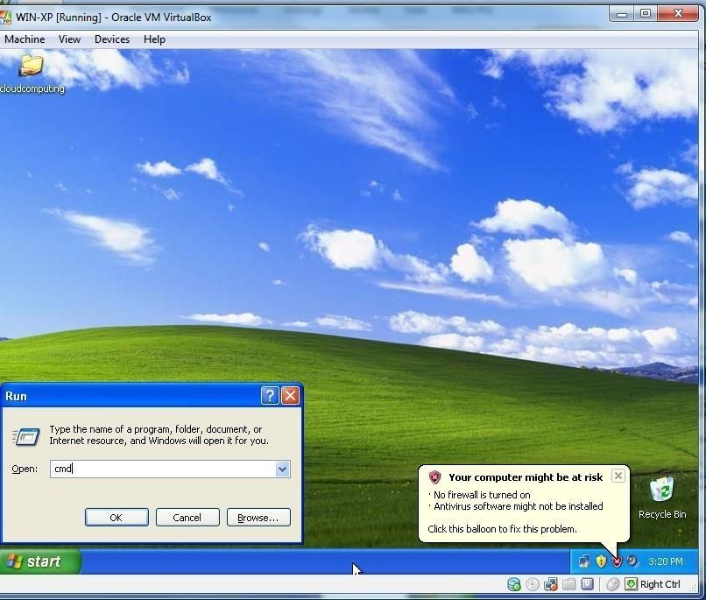

Step 10: type “ipconfig” to view the ip address of the virtual machine 1.

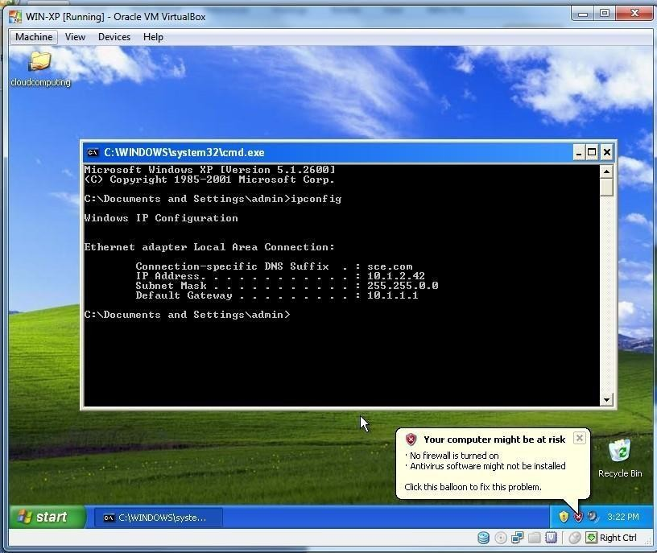

Step 11: In virtual machine 2, open the run command and type the Ip address of virtual machine 1.

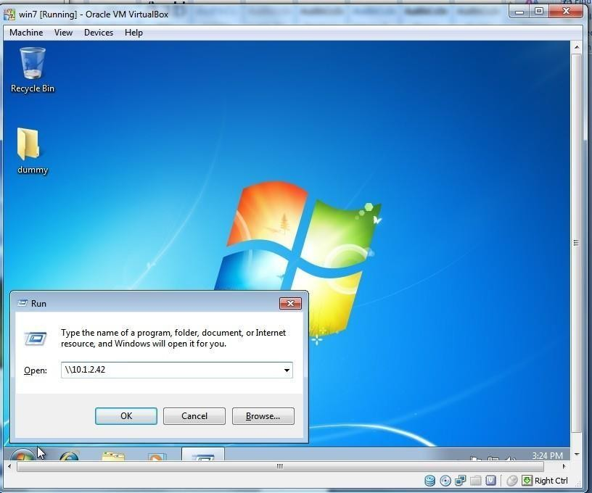

Step 12: Now, We can access the shared folder of virtual machine 1 in network place of virtual machine 2.

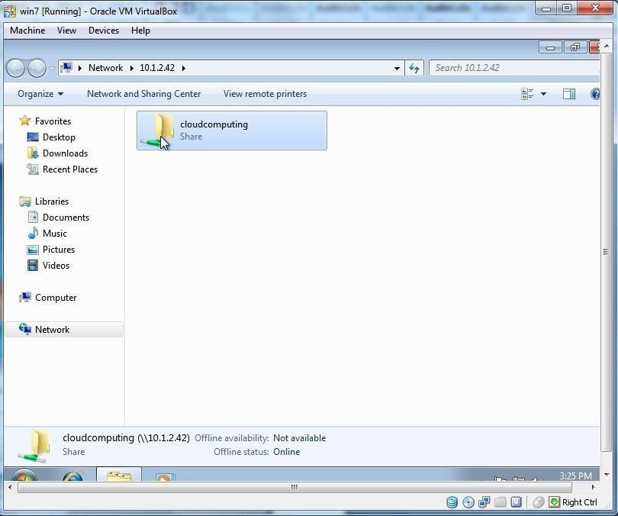

Step 13: After opening the shared folder, we can copy the required files in virtual machine 2.

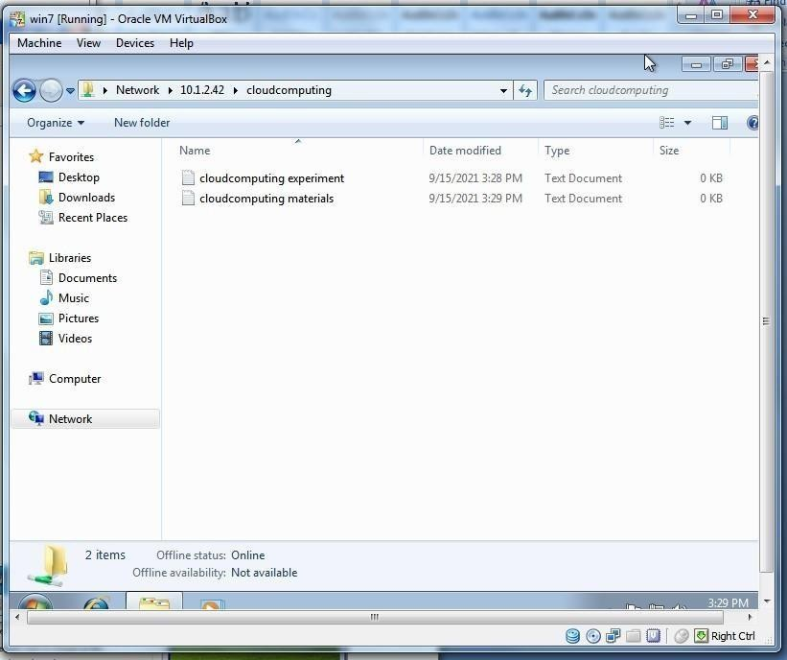

## Result:

# EX. No.: 7 Install Hadoop single node cluster and run a simple application Date:

**Aim:**

# Procedure:

Part 1: Installation of Hadoop single node cluster: Open the terminal in Ubuntu: Step 1: Update the packages

$ sudo apt-get update

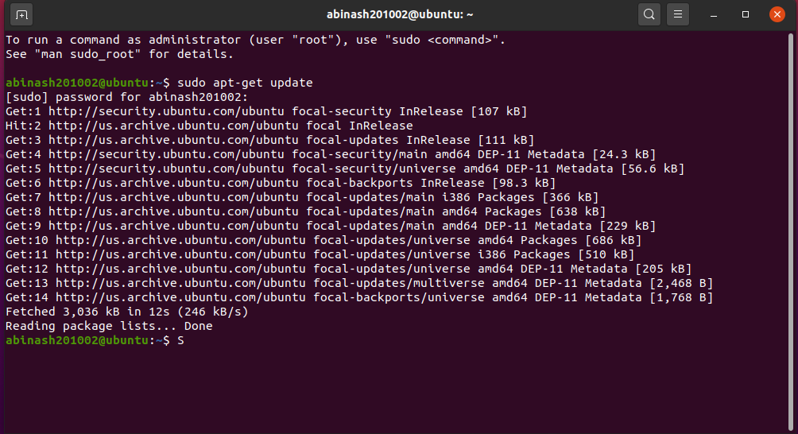

Step 2: Installing java

$ sudo apt-get install default-jdk

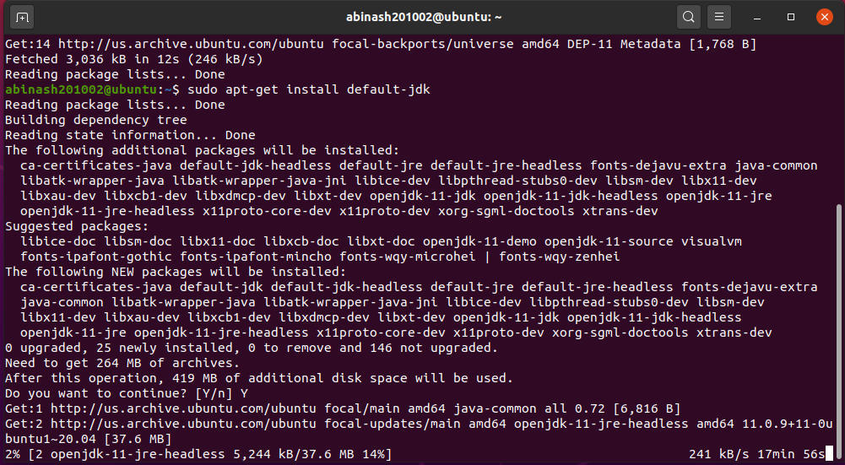

Step 3: Assigning a dedicated user on hadoop to perform operations

*First create a group:

$ sudo addgroup hadoop

*Next create a user:

$ sudo adduser --ingroup hadoop abinash

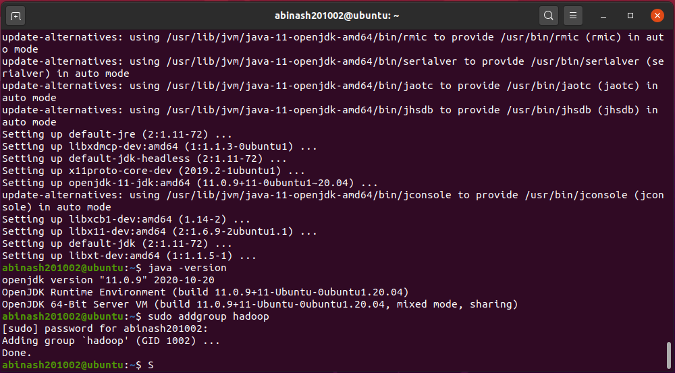

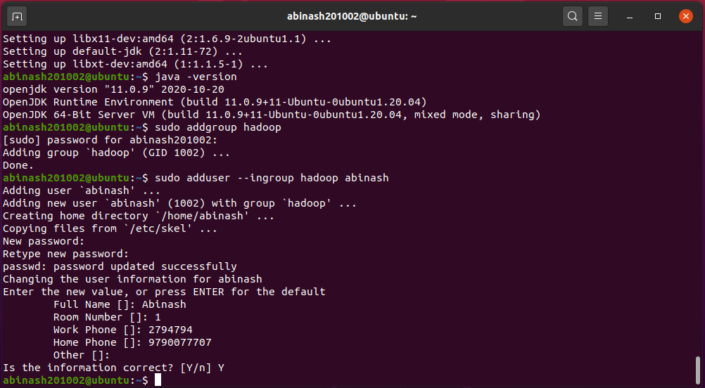

Step 4: Adding user to sudo list

$ sudo adduser abinash sudo

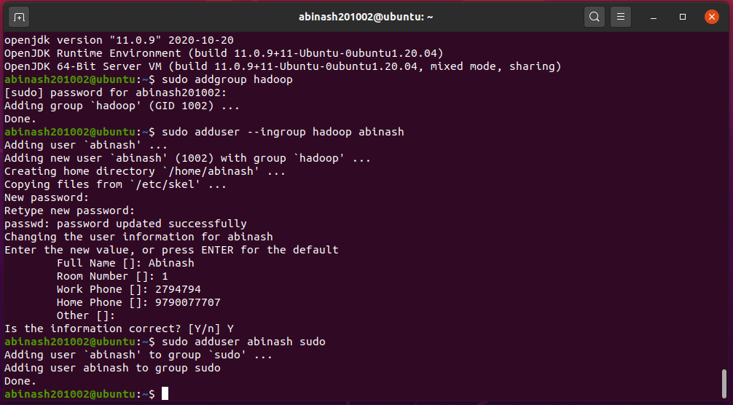

Step 5: Next install a package ssh(secured shell login)

$ sudo apt-get install openssh-server

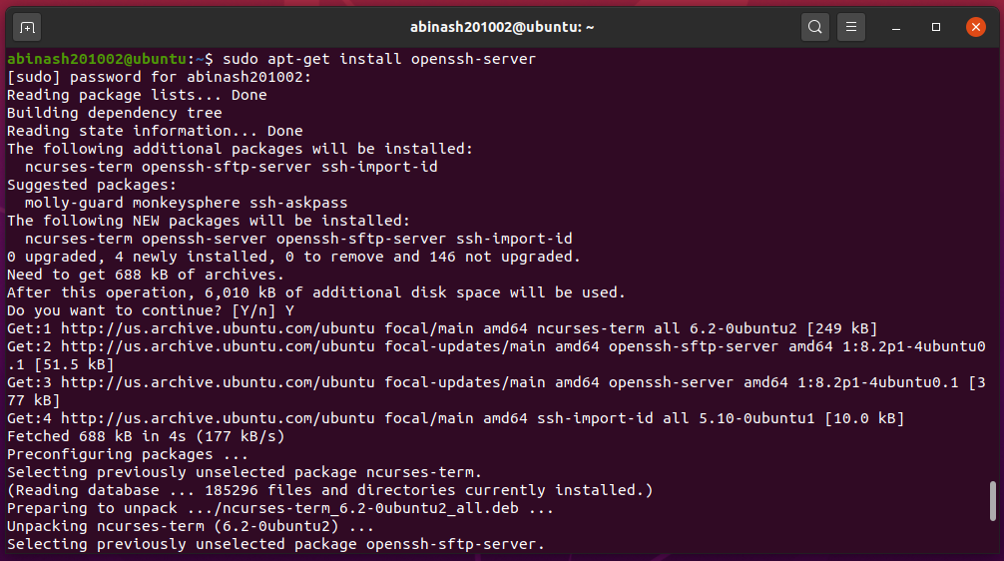

Step 6: Now login the new user (dedicated user)

$ su – abinash

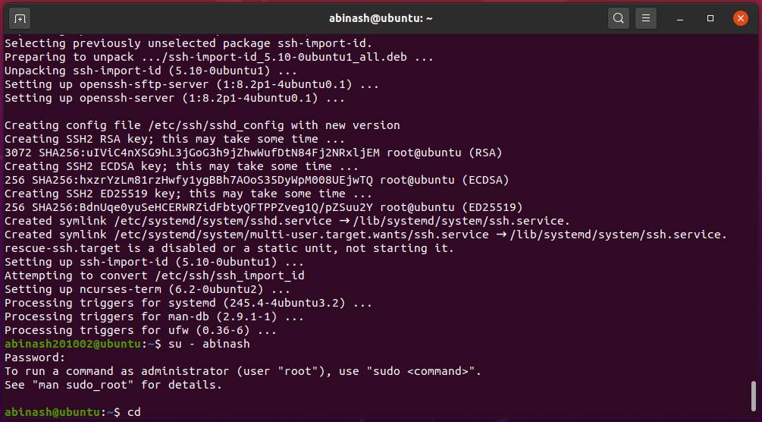

Step 7: Next step is key generation

$ ssh-keygen -t rsa -P " "

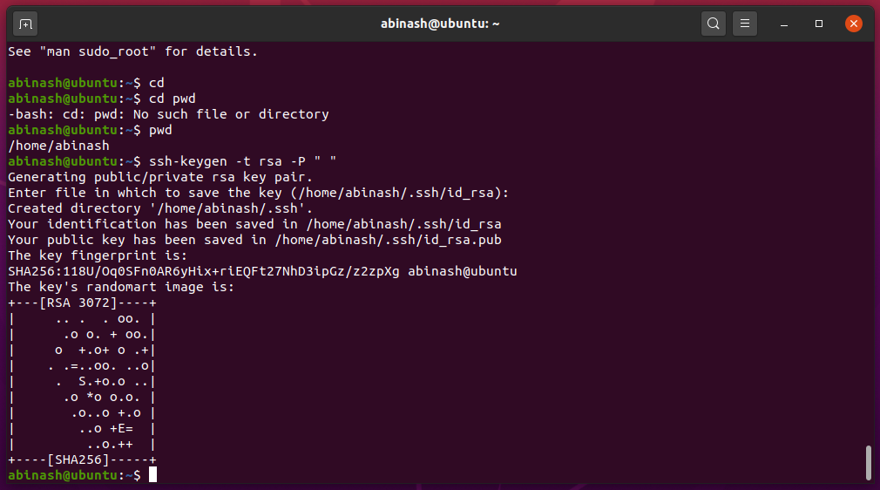

Step 8: Add key to a file

$ cat $HOME/.ssh/id_rsa.pub >> $HOME/.ssh/authorized_keys

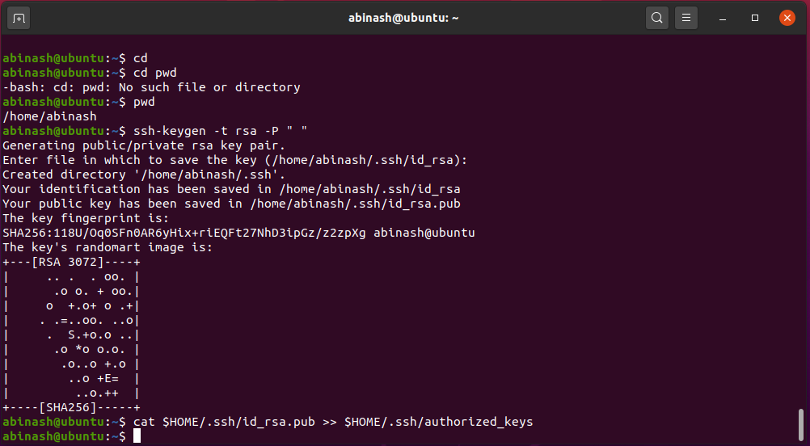

Step 9: To check whether ssh is installed properly by logging in and after that exit from it

$ ssh localhost

$ exit

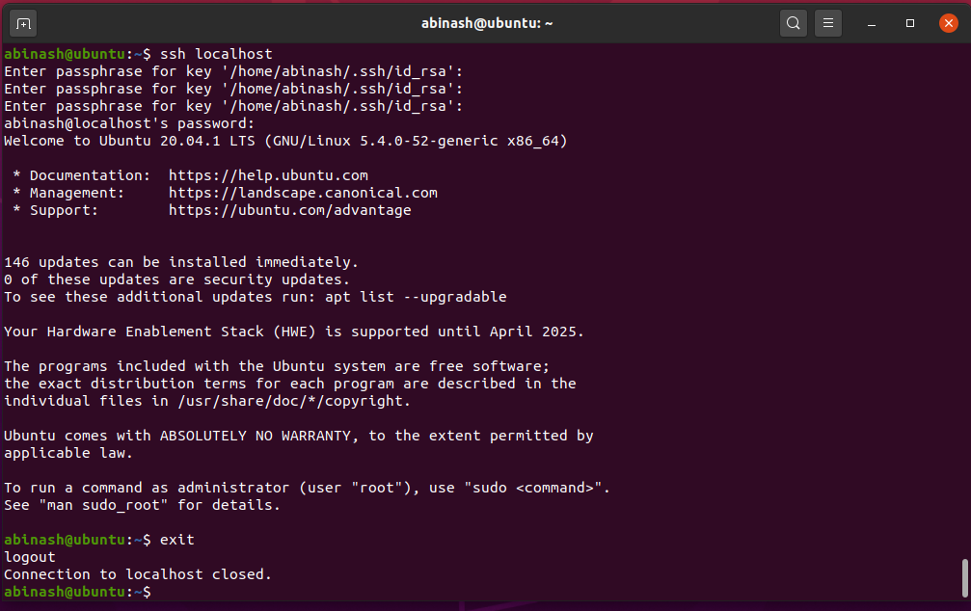

Step 10: Download using this link: https://downloads.apache.org/hadoop/common/

*Click on hadoop-2.9.2/

*The click on hadoop-2.9.2.tar.gz

*You can find the "hadoop-2.9.2.tar.gz" in the downloads.

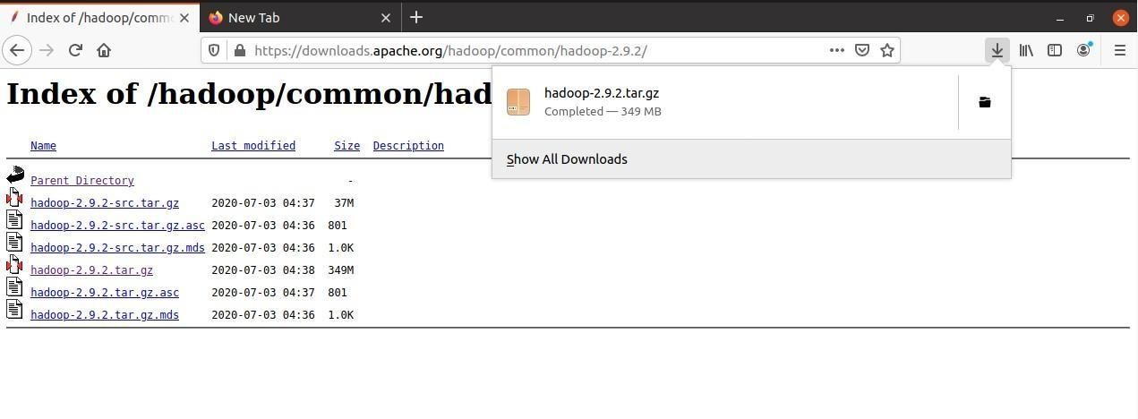

Step 11: Now extract the tar file.

*Change the directory

$ cd /home/abinash201002/

$ cd Desktop/

$ ls //you can find the file “hadoop-2.9.2.tar.gz"

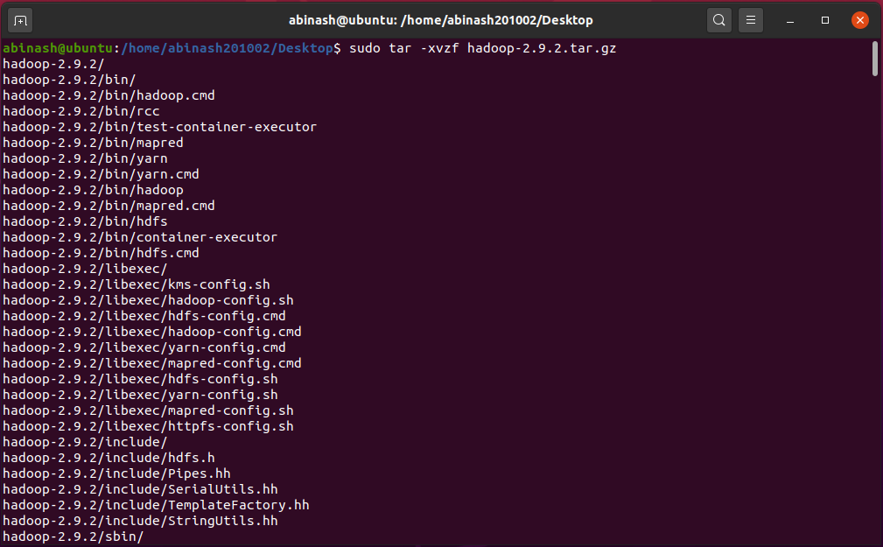*Now to extract $ sudo tar -xvzf hadoop-2.9.2.tar.gz

Step 12: Move the file to local

$ sudo mv hadoop-2.9.2 /usr/local/hadoop

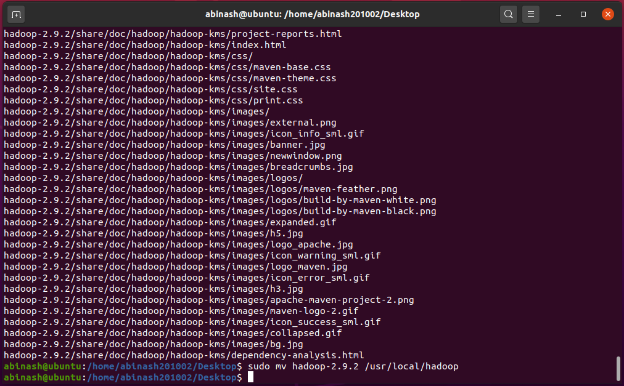

Step 13: Change the ownership of hadoop folder

$ sudo chown -R sample /usr/local

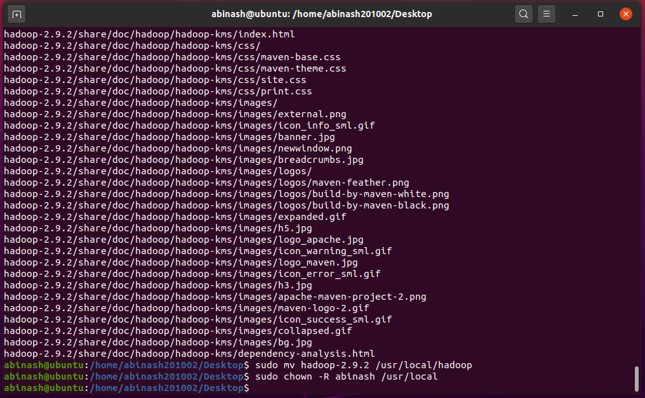

Step 14: First .bashrc file

$ sudo nano ~/.bashrc

*Now add the following code at the end (to add env var) export JAVA_HOME=/usr/lib/jvm/java-8-openjdk-amd64 export HADOOP_HOME=/usr/local/hadoop

export PATH=$PATH:$HADOOP_HOME/bin export PATH=$PATH:$HADOOP_HOME/sbin

export HADOOP_MAPRED_HOME=$HADOOP_HOME export HADOOP_COMMON_HOME=$HADOOP_HOME export HADOOP_HDFS_HOME=$HADOOP_HOME

export YARN_HOME=$HADOOP_HOME

export HADOOP_COMMON_LIB_NATIVE_DIR=$HADOOP_HOME/lib/native export HADOOP_OPTS="-Djava.library.path=$HADOOP_HOME/lib"

*After pasting Crtl+O(for writing) and then press enter. Then press Ctrl+X(for exiting).

*Now make it as a source

$ source ~/.bashrc

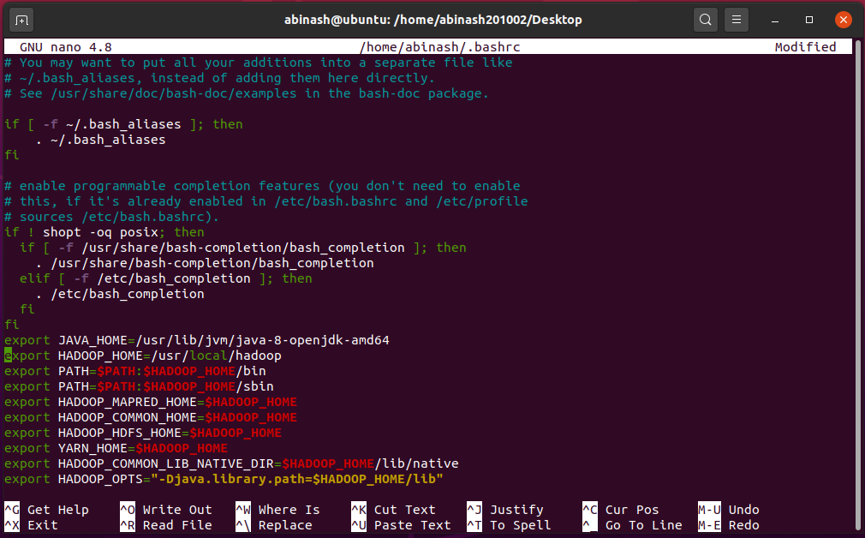

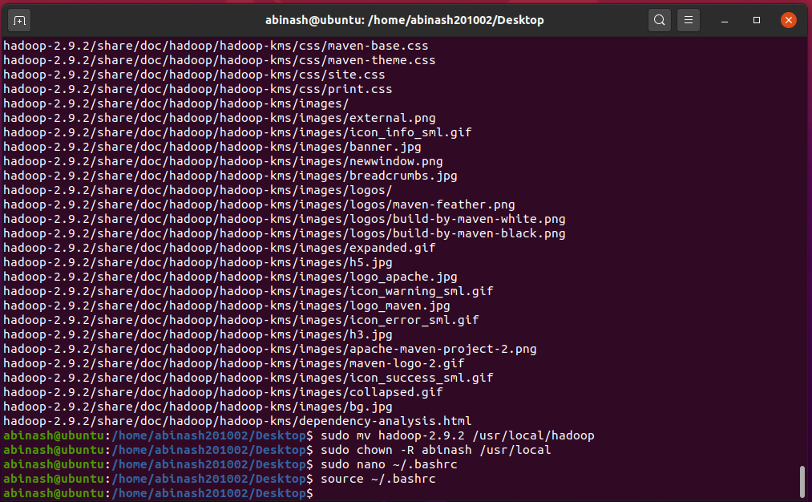

Step 15: Specify the Java path to Hadoop

*Open "hadoop-env.sh" file for this:

$ sudo nano /usr/local/hadoop/etc/hadoop/hadoop-env.sh

Now comment the line "export JAVA_HOME=$(JAVA_HOME)" and add the follwing line:

export JAVA_HOME=/usr/lib/jvm/java-11-openjdk-amd64

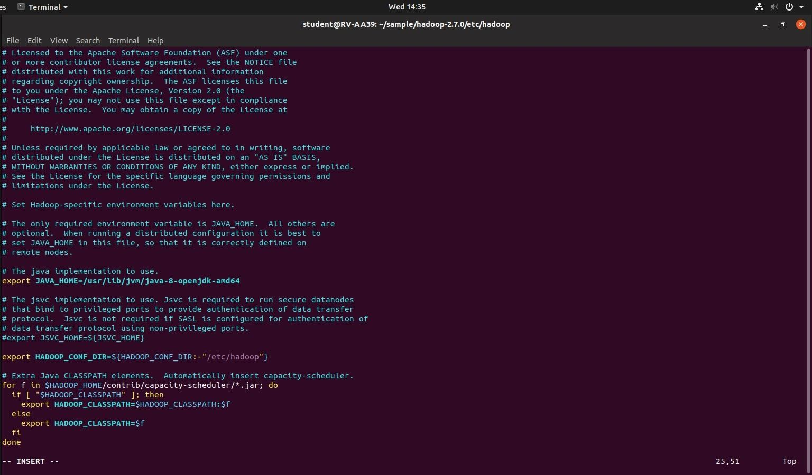

Step 16: Now open the file "core-site.xml"

$ sudo nano /usr/local/hadoop/etc/hadoop/core-site.xml

*Now add the following code inside <configuration> </configuration>:

<property>

<name>fs.default.name</name>

<value>hdfs://localhost:9000</value>

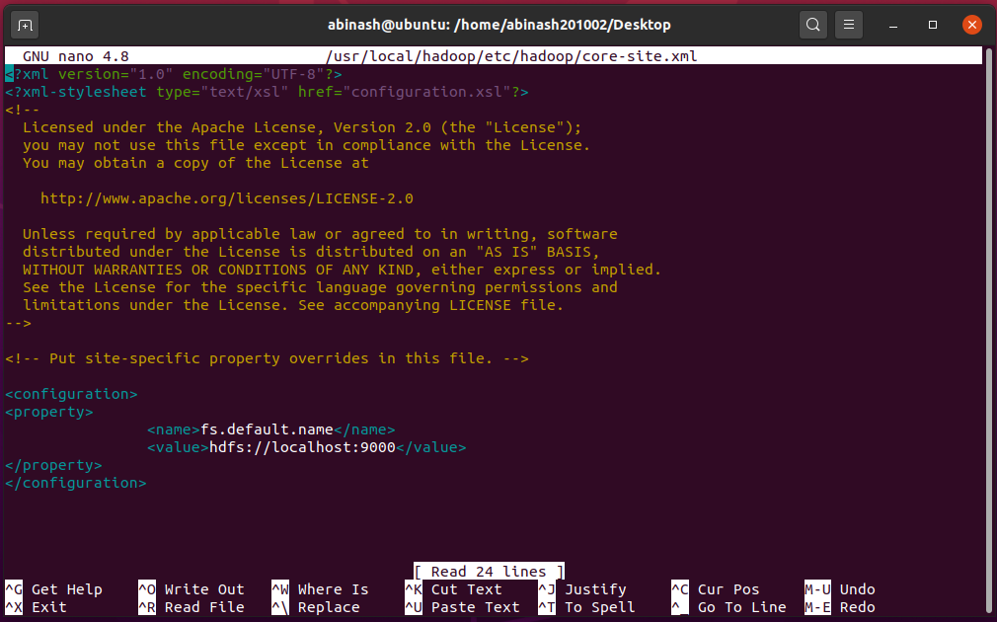</property>

Step 17: Now open the file "hdfs-site.xml"

$ sudo nano /usr/local/hadoop/etc/hadoop/hdfs-site.xml

*Now add the following code inside <configuration> </configuration>:

<property>

<name>dfs.replication</name>

<value>1</value>

</property>

<property>

<name>dfs.namenode.name.dir</name>

<value>file:/usr/local/hadoop_tmp/hdfs/namenode</value>

</property>

<property>

<name>dfs.datanode.data.dir</name>

<value>file:/usr/local/hadoop_tmp/hdfs/datanode</value>

</property>

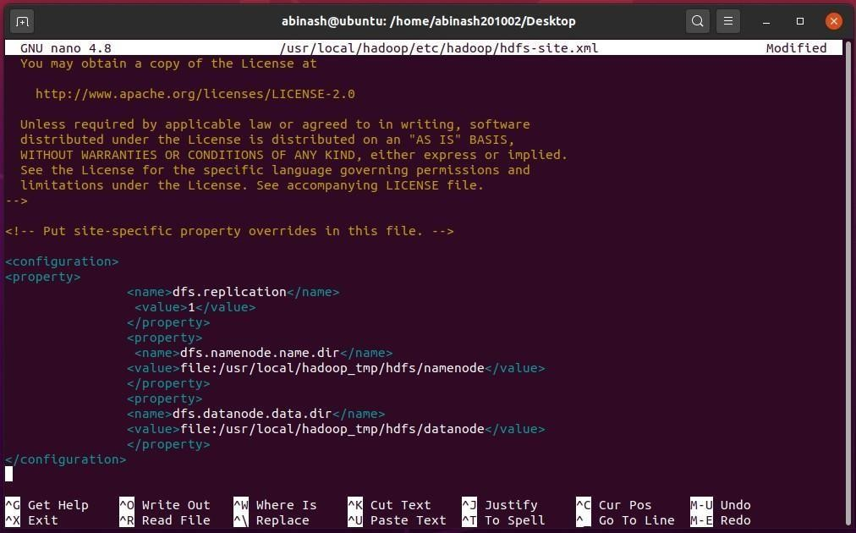

Step 18: Now open the file "yarn-site.xml"

$ sudo nano /usr/local/hadoop/etc/hadoop/yarn-site.xml

*Now add the following code inside <configuration> </configuration>:

<property>

<name>yarn.nodemanager.aux-services</name>

<value>mapreduce_shuffle</value>

</property>

<property>

<name>yarn.nodemanager.aux-services.mapreduce.shuffle.class</name>

<value>org.apache.hadoop.mapred.ShuffleHandler</value>

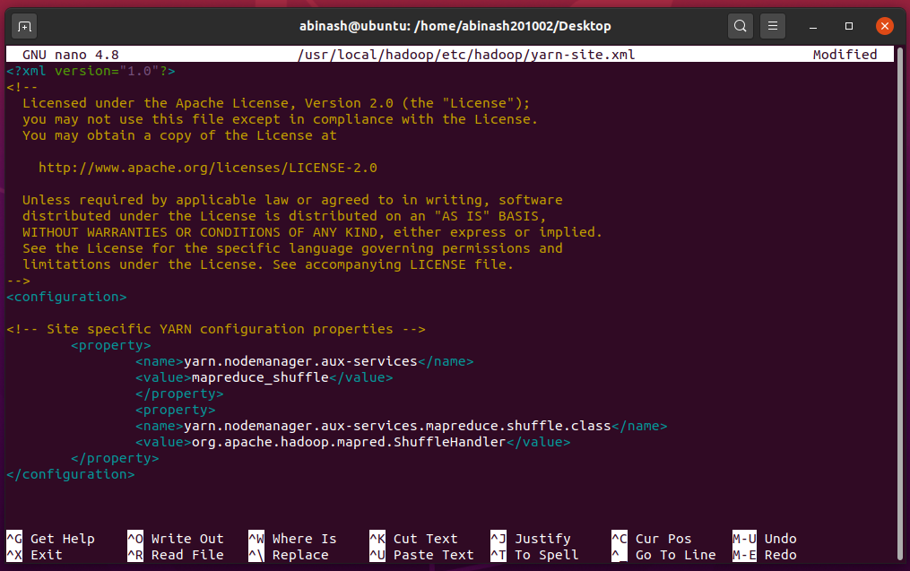</property>

Step 19: Change filename from "mapred-site.xml.template" to "mapred-site.xml" using:

$ sudo cp /usr/local/hadoop/etc/hadoop/mapred-site.xml.template

/usr/local/hadoop/etc/hadoop/mapred-site.xml

*Now open the file "mapred-site.xml"

$ sudo nano /usr/local/hadoop/etc/hadoop/yarn-site.xml

*Now add the following code inside <configuration> </configuration>:

<property>

<name>mapreduce.framework.name</name>

<value>yarn</value>

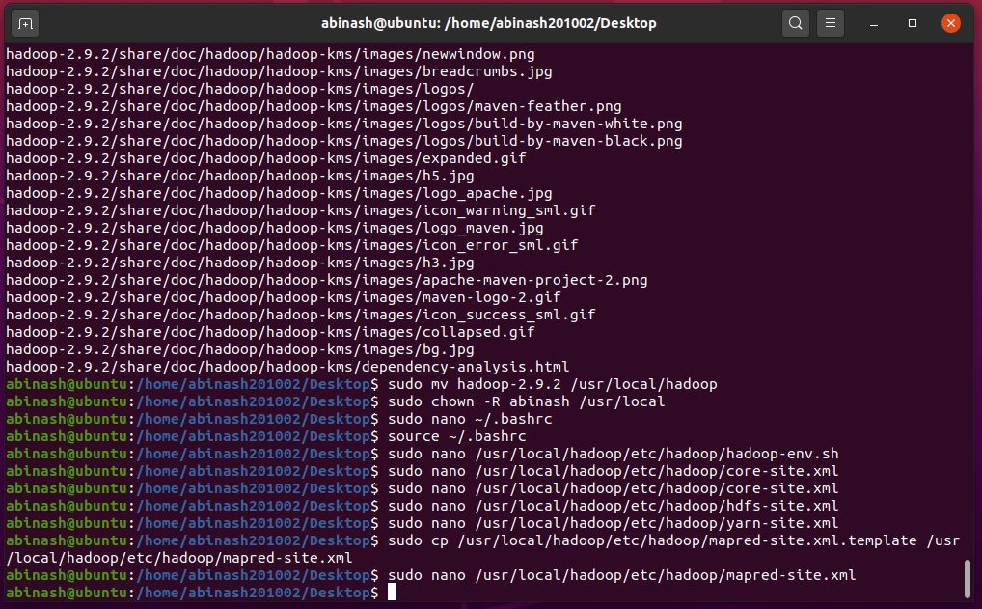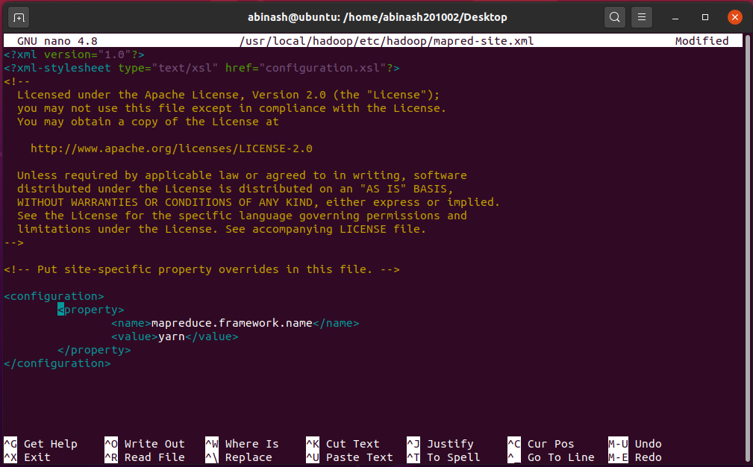</property>

Step 20:

$ sudo mkdir -p /usr/local/hadoop_tmp

$ sudo mkdir -p /usr/local/hadoop_tmp/hdfs/namenode

$ sudo mkdir -p /usr/local/hadoop_tmp/hdfs/datanode

*Now assign the ownership to the dedicated user for this directory using:

$ sudo chown -R abinash /usr/local/hadoop_tmp

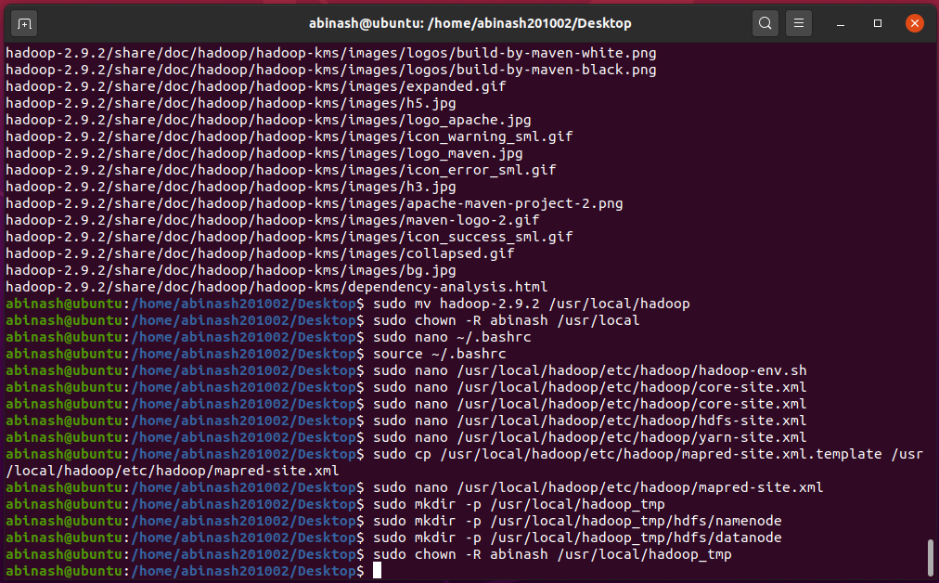

Now we have to format hdfs namenode Step 21: $ cd

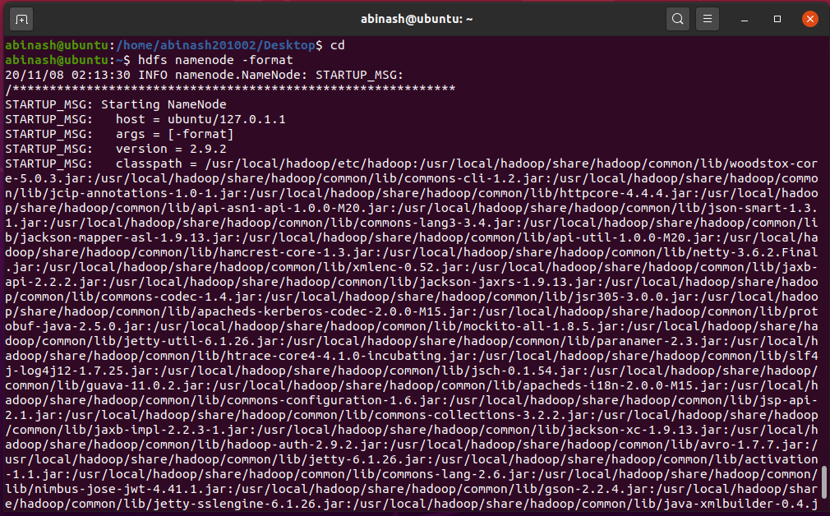$ hdfs namenode -format

Next, we have start the DFS Step 22:

$ start-dfs.sh

$ start-yarn.sh

*To check whether hadoop is correctly installed or not:

$ jps

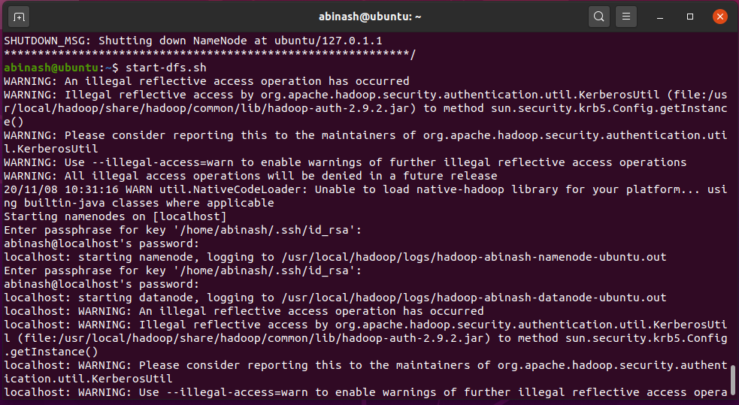

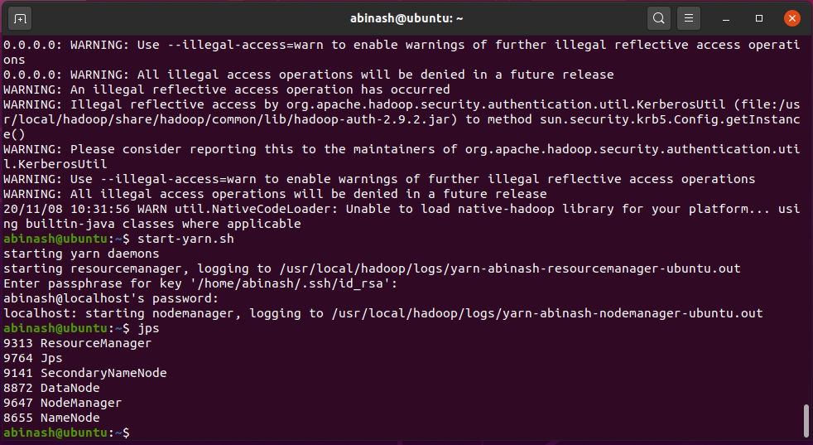

**Now we have created a single node cluster.**

**Now we have to run a "Word count" program on HDFS by passing a input.**

Step 23:

$ cd /home/abinash201002/Desktop/

*Now create a directory called data:

$ sudo mkdir data

$ cd data/

*Now open a file "sample.txt" and type the input:

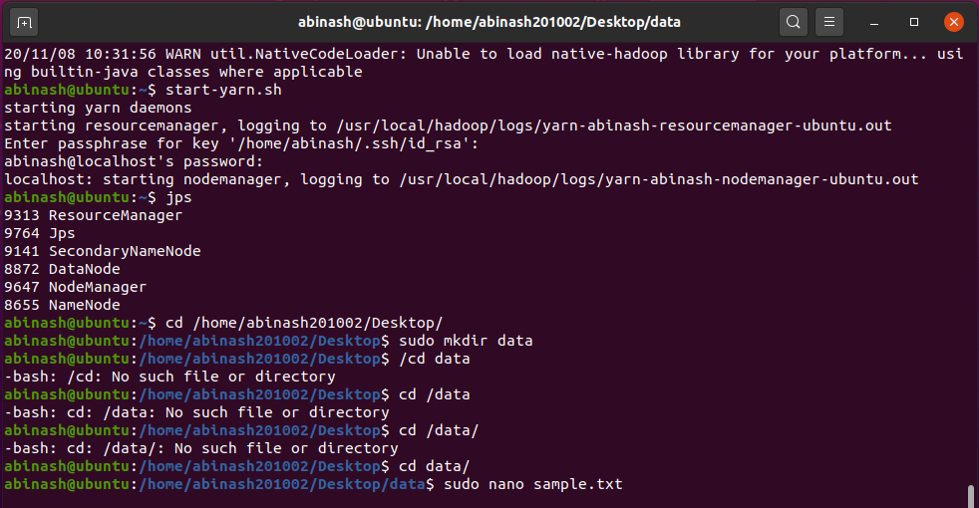$ sudo nano sample.txt

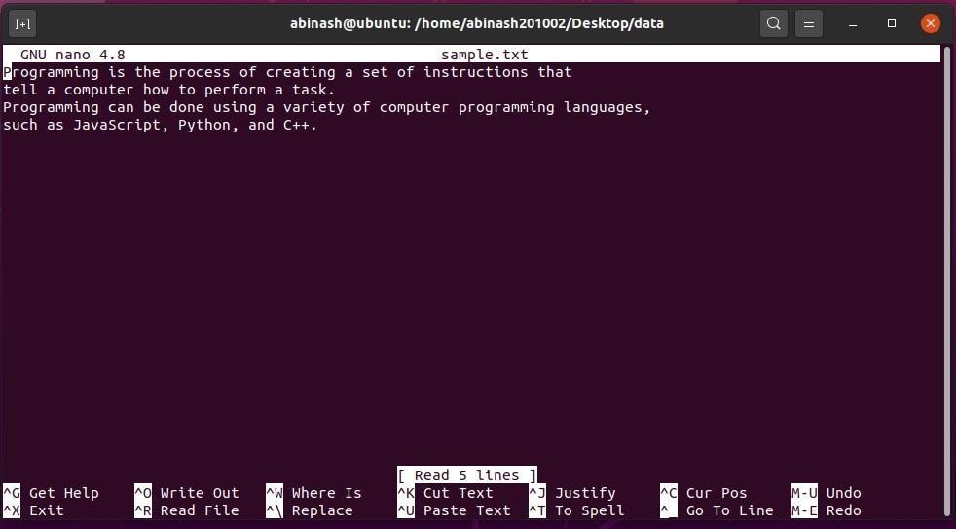

Step 24:

$ cd

$ cd /usr/local/hadoop

$ bin/hdfs dfs -mkdir /user

$ bin/hdfs dfs -mkdir /ypm

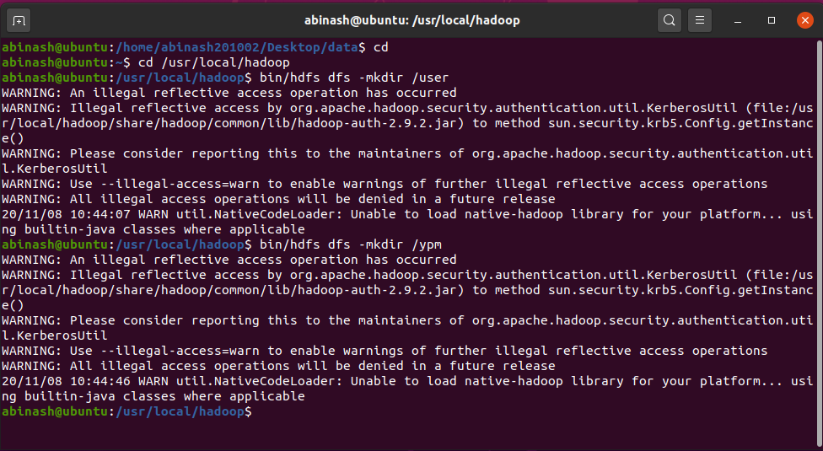

Step 25: $ bin/hdfs dfs -put /home/abinash201002/Desktop/data /user/input //for copying sample.txt to hdfs

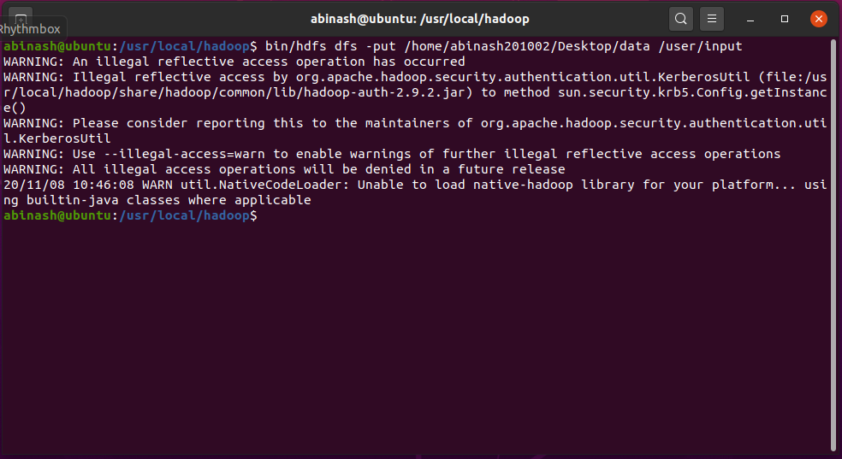

Step 26: Run the word count program will be in the jar file by default which we are using now.

$ bin/hadoop jar share/hadoop/mapreduce/hadoop-mapreduce-examples-2.9.2.jar WordCount /user/input output

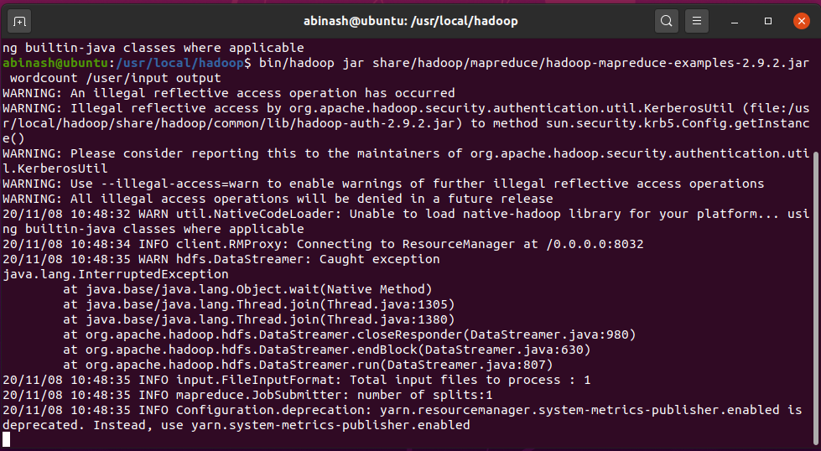

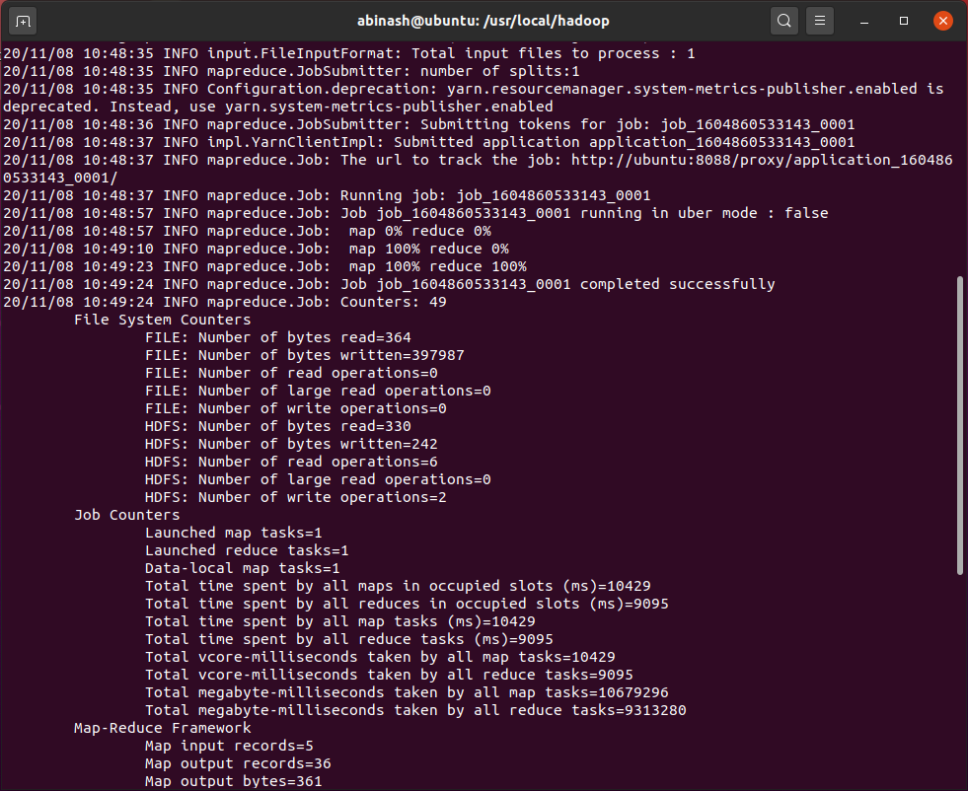

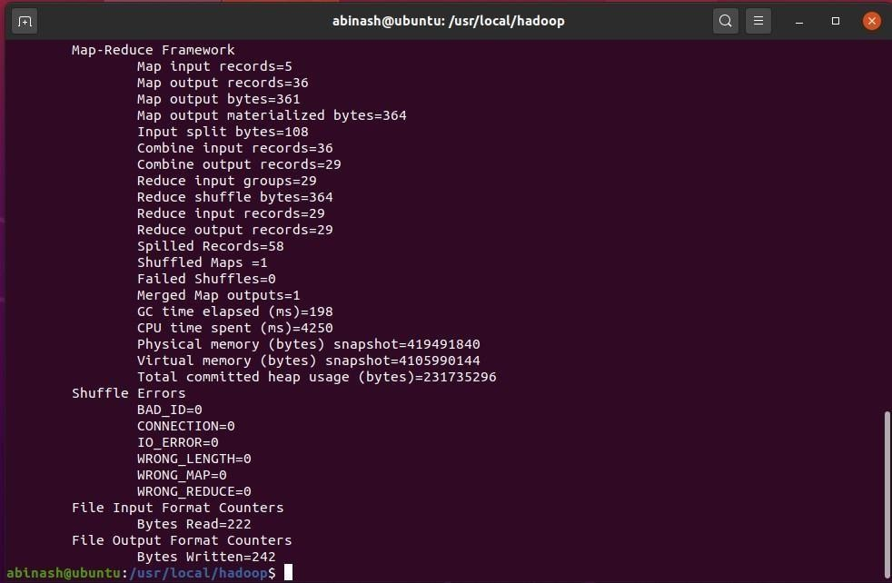

Step 27: Now run the following command to see the output

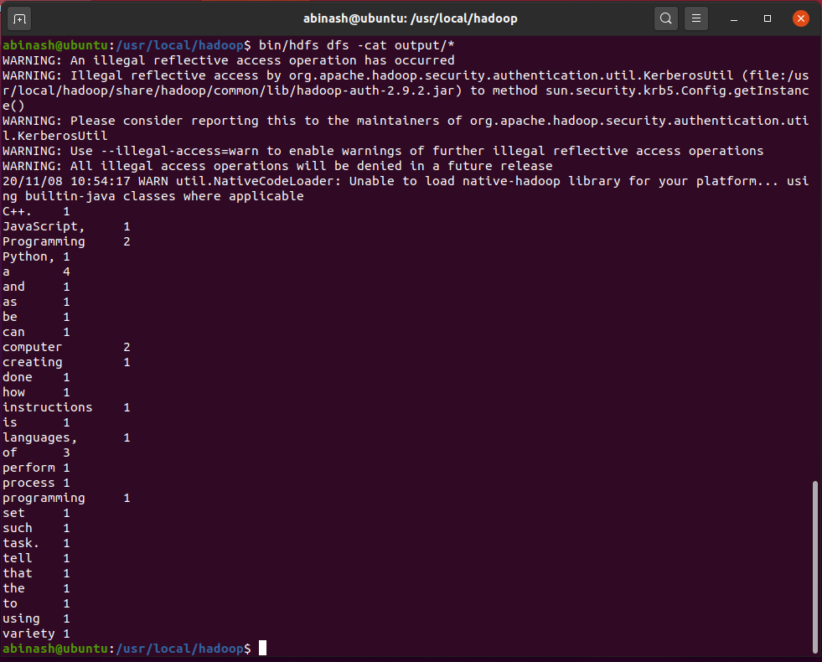$ bin/hdfs dfs -cat output/*

For GUI interface (hadoop must be running) Open browser and type localhost:50070

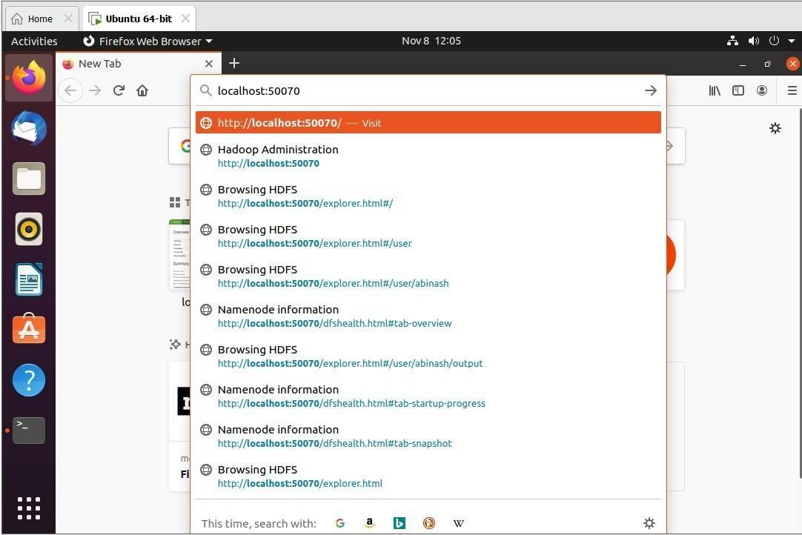

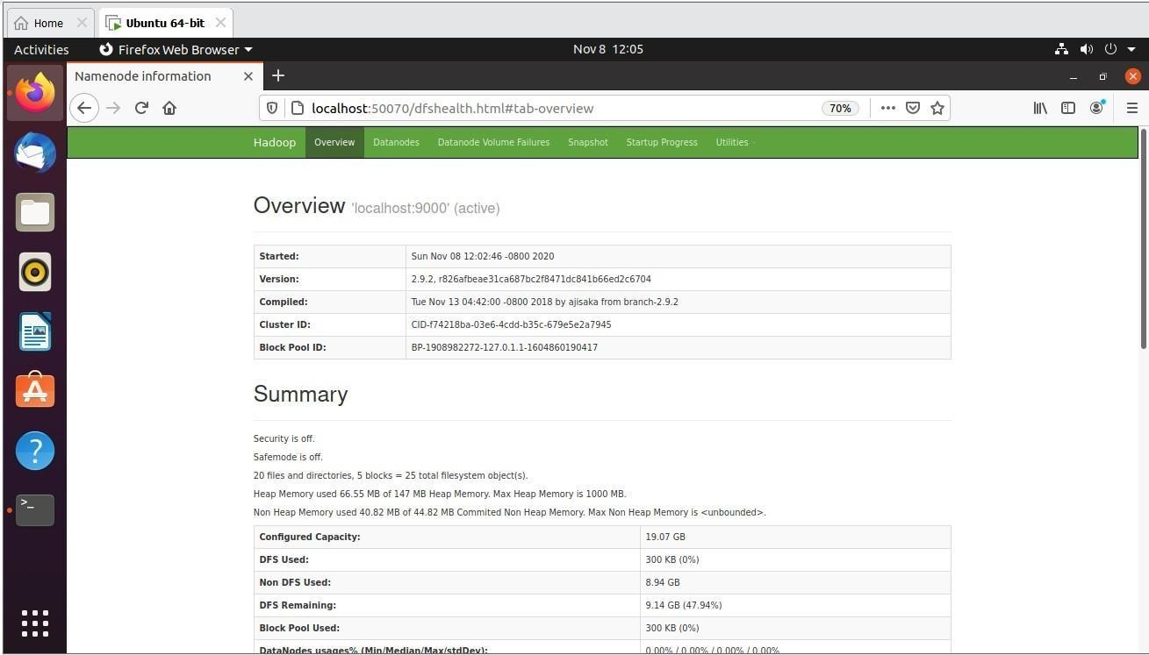

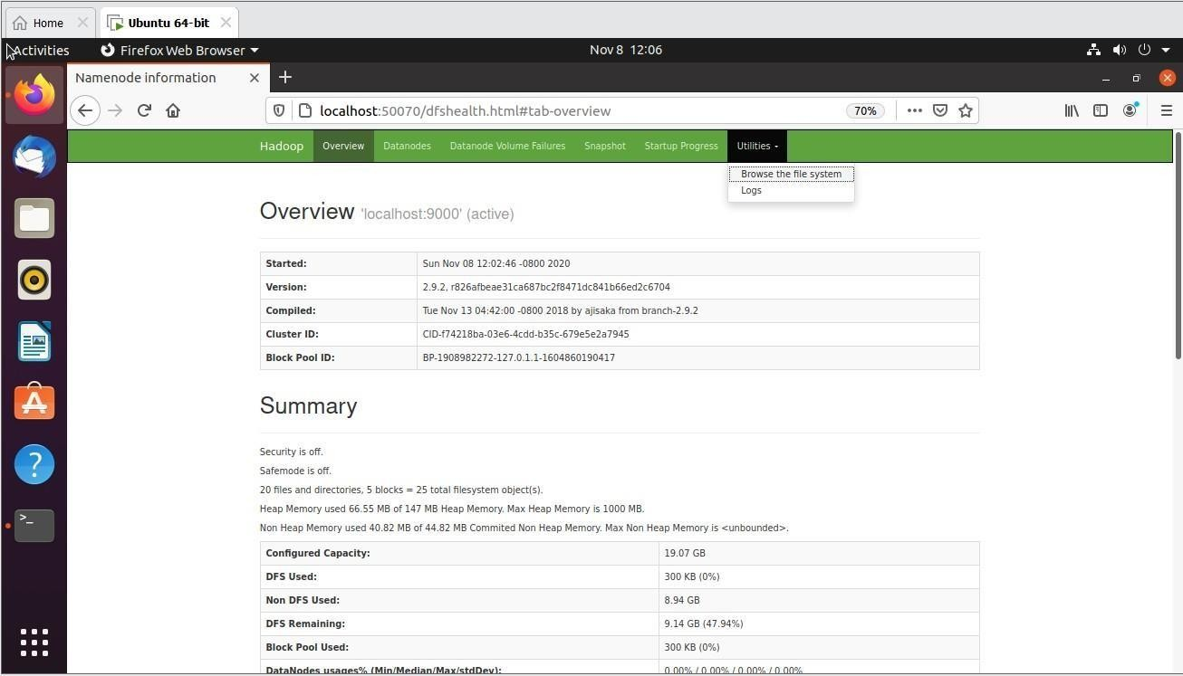

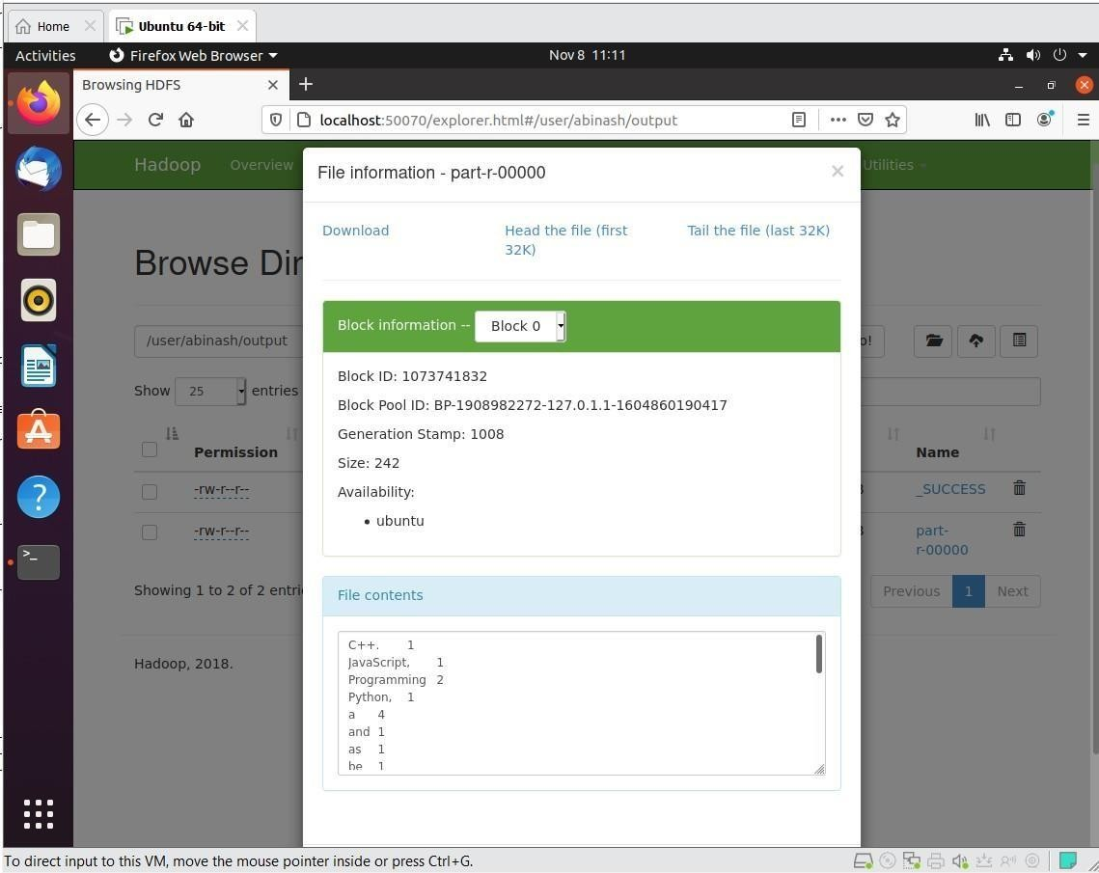

After completing stop hadoop

$ stop-all.sh

*To check whether it has stopped

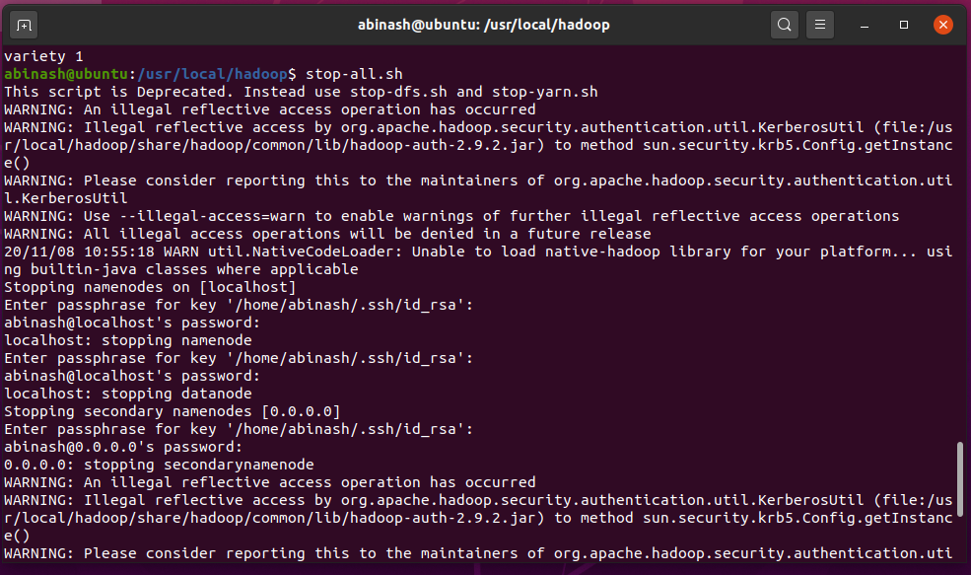$ jps

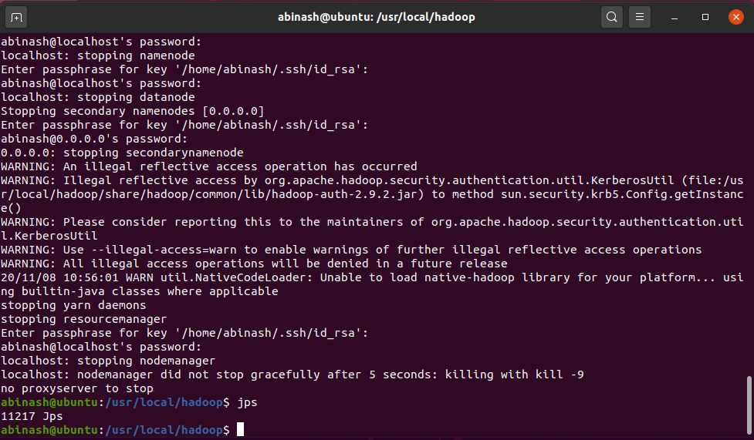

# Result:

# EX. No.: 8 Creating and Executing First Container Using Docker

# Date:

**Aim:**

# Procedure:

Step 1: Create a docker hub image library. Search for Docker hub.

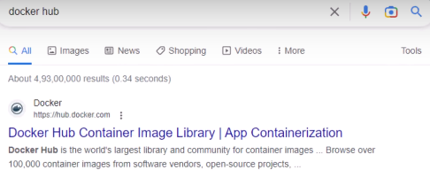

Step 2: Click Explore in docker hub.

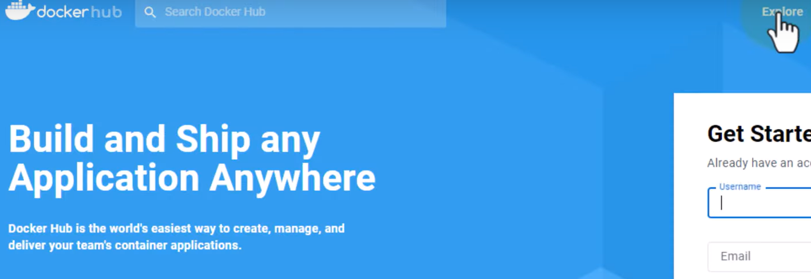

Step 3: Search for hello world docker official image.

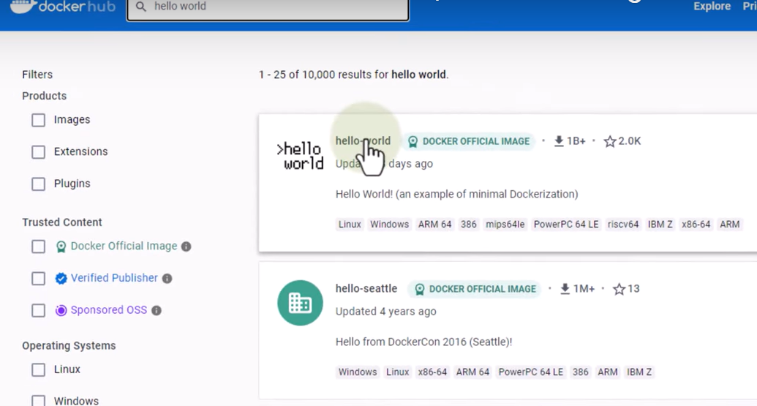

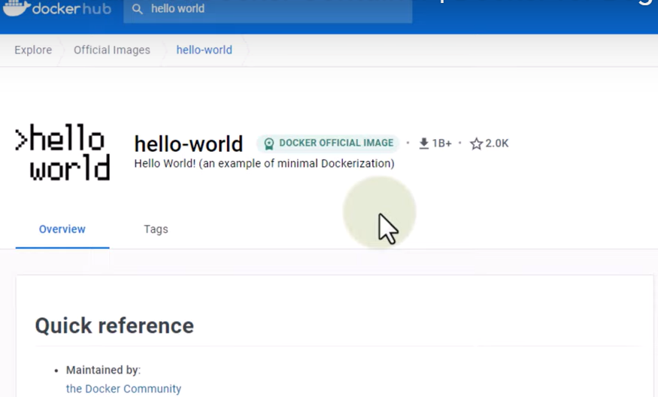

Step 4: Now run the hello world program from docker in the terminal.

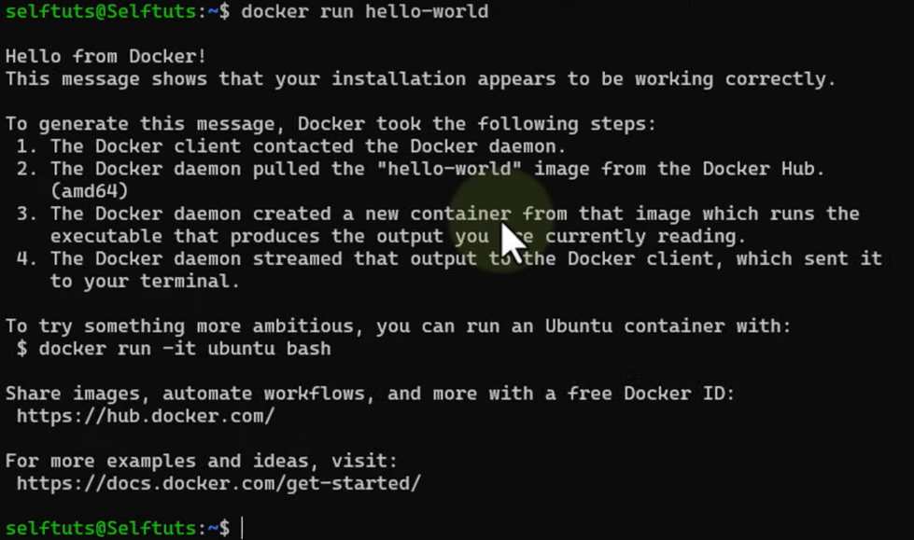

Step 5: Run docker pc to list docker containers.

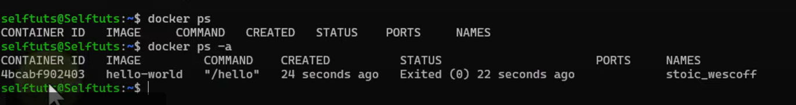

Step 6: Thus the first container using docker is created and executed successfully using hello world.

**Result:**

# EX. No.: 9 Run a Container from Docker

# Date:

**Aim:**

# Procedure:

Step 1: Create a docker hub image library. Search for Docker hub.



Step 2: Sign-up and create a new docker id with username and password.

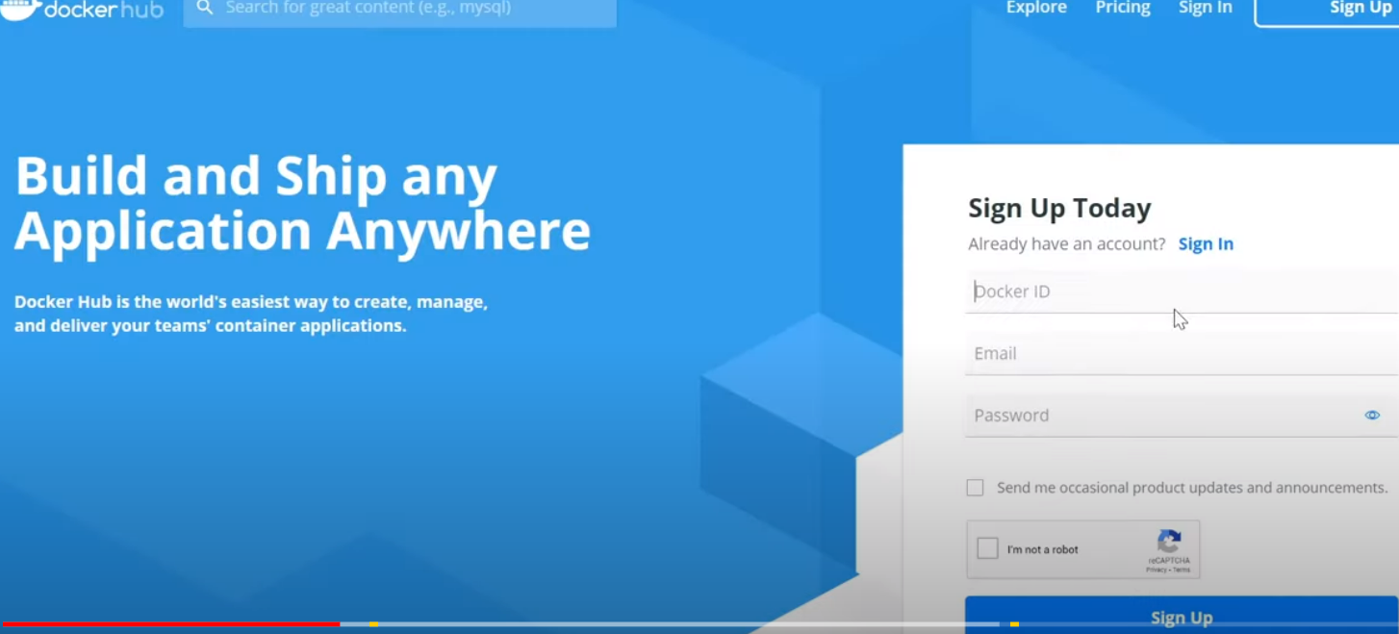

Step 3: Now after creating docker id, sign in with the docker – id.

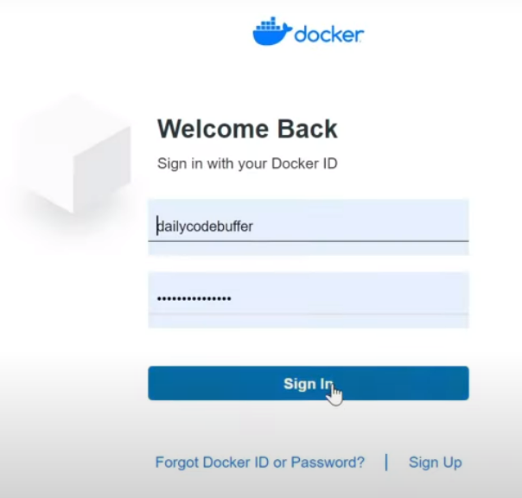

Step 4: Click tab repositories, in docker hub.

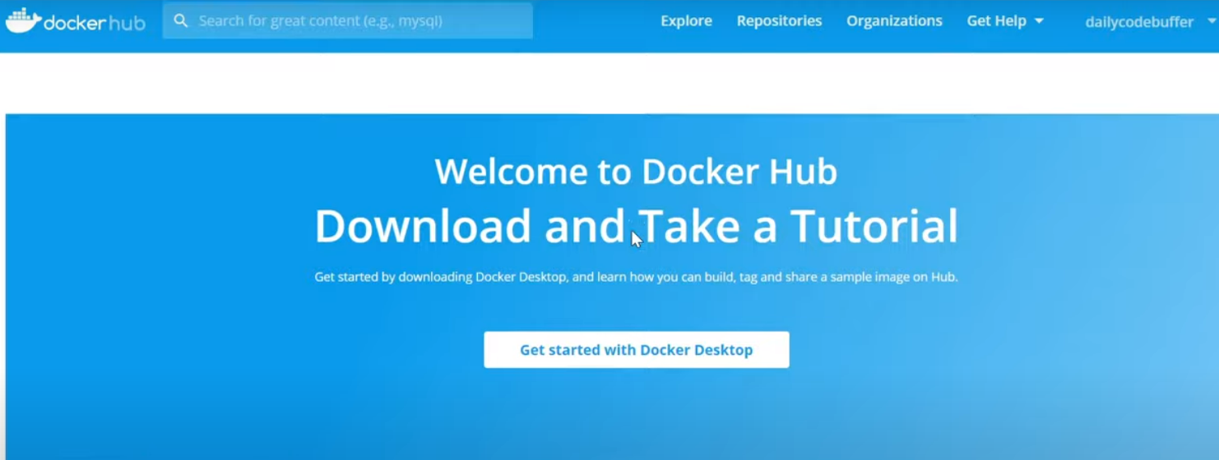

Step 5: Open terminal and run doicker images.

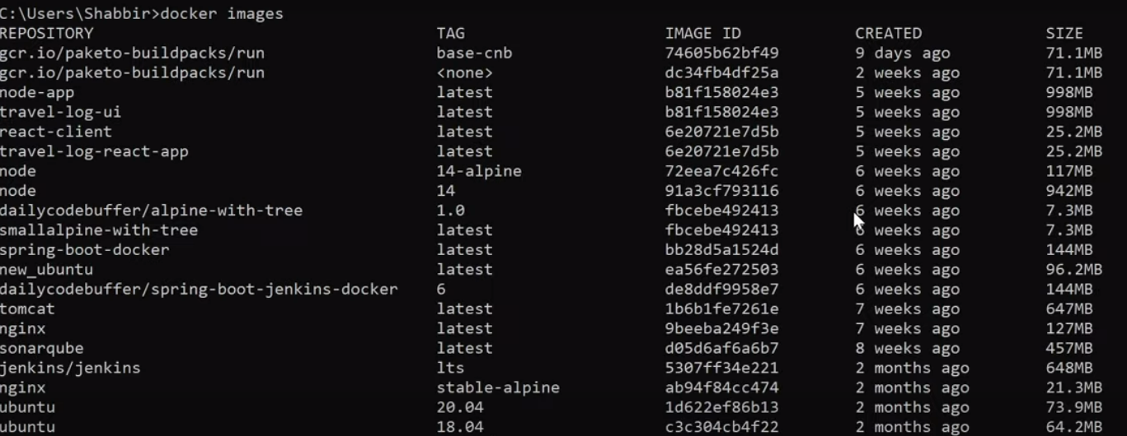



Step 6: Enter with docker login.

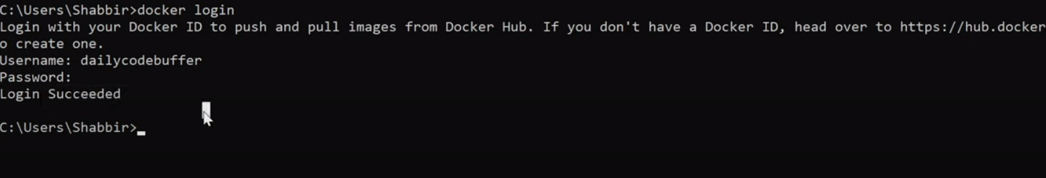

Step 7: Use docker tag from step 5 as buildpackdemo and its version



Step 8: Use docker push command to push the latest version of buildpackdemo from docker images.



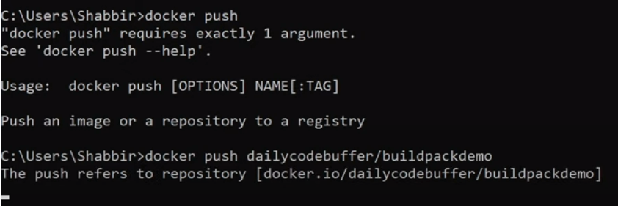

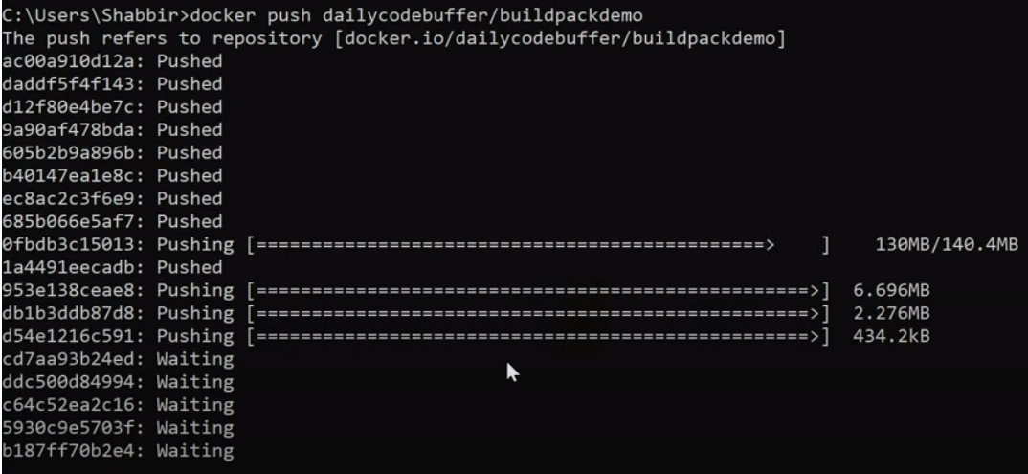

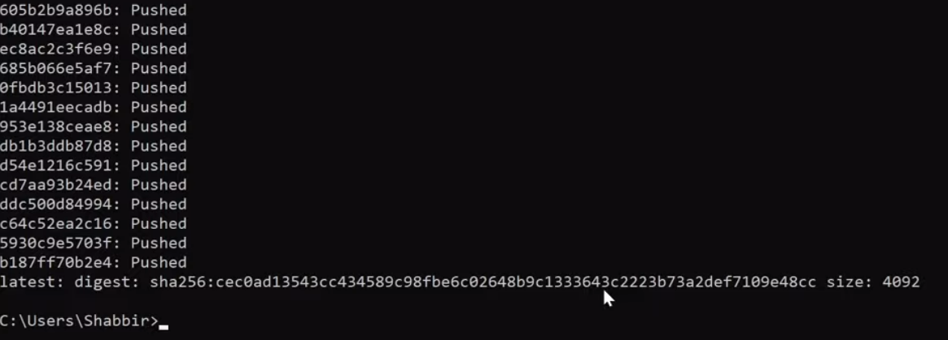

Step 9: Now the contents are pushed to docker. Hence, open the docker hub and check for the buildpackdemo. Now you can find the contents.

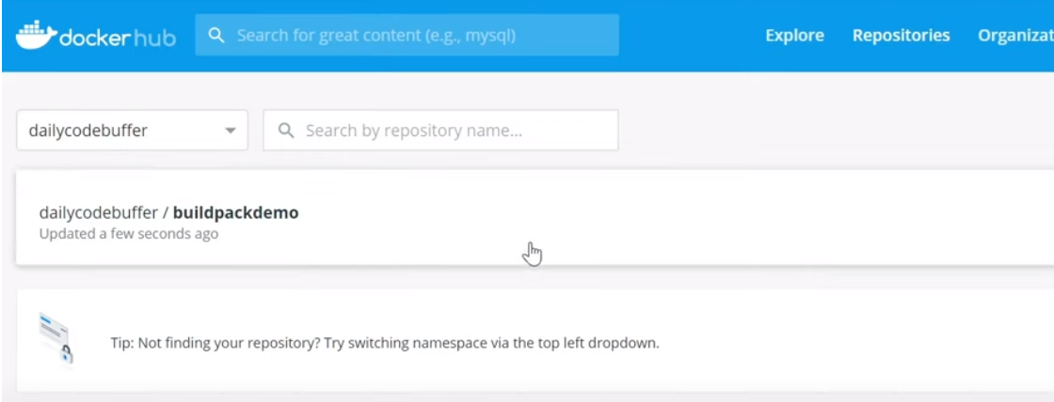

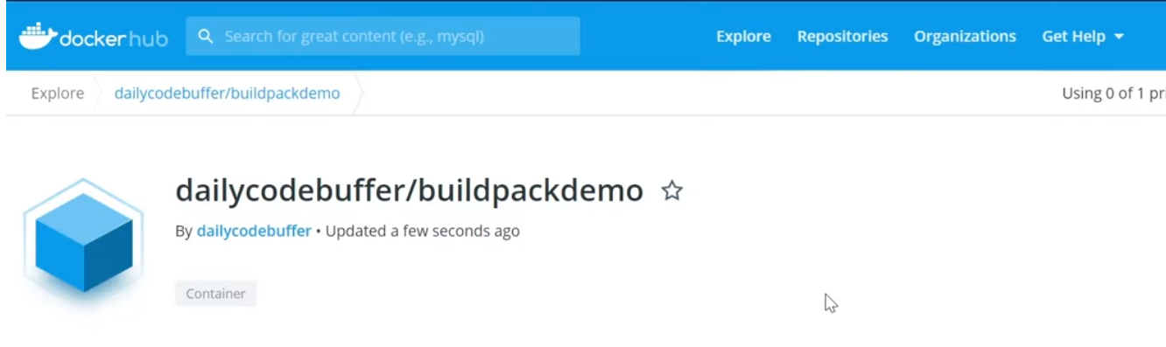

Step 10: Now copy the docker pull command.

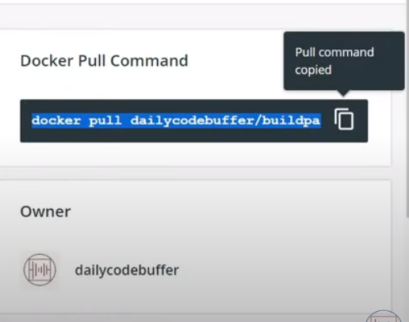

Step 11: Type the command in terminal.

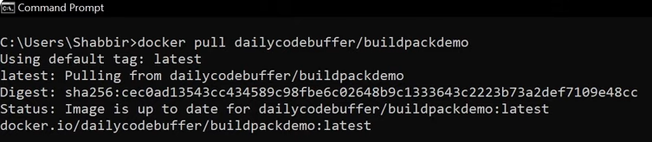

Step 12: Run the docker rmi buildpackdemo command and pull it.



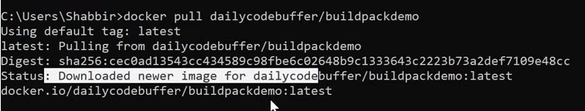

Step 13: Run the docker.

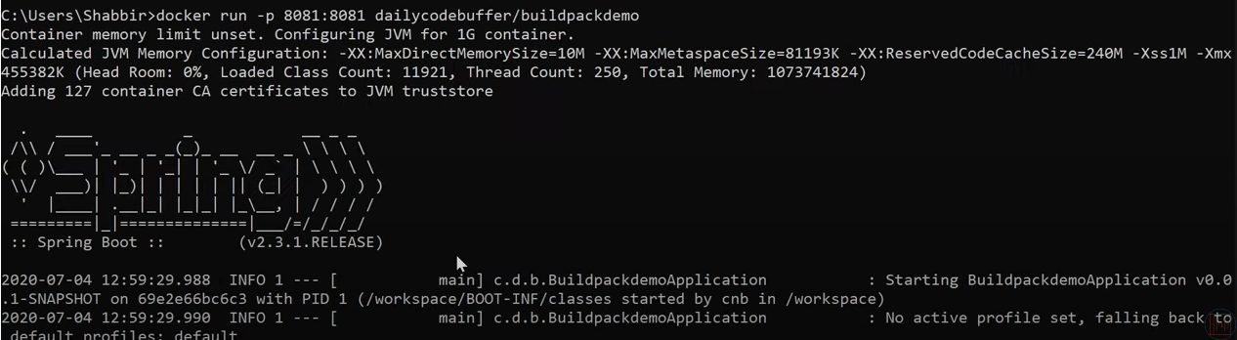

Step 13: Run the docker hub localhost:8081

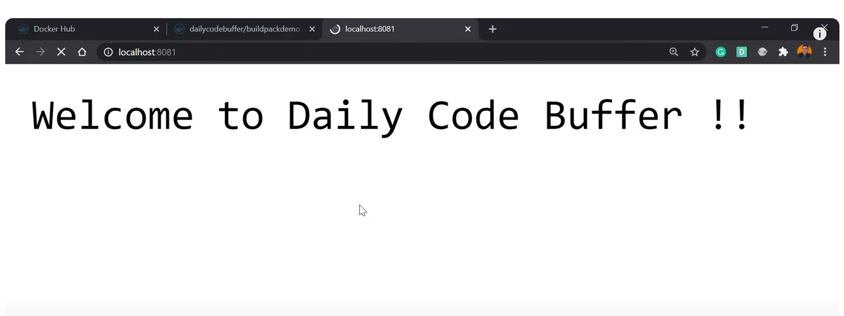

Step 14: Thus the container is run from docker hub.

**Result:**